Iceland 2018 – Sue & Christopher

September 21, 2018 through October 4, 2018

Our adventure began, as it always does, at the YBH. But unlike many of our trips, which often start in the wee hours of the morning, this one wasn’t set to commence until the afternoon. We arrived at BDL in mid-afternoon on Friday, September 21, 2018 and were shuttled to the terminal in plenty of time for our scheduled departure. As we rode in the shuttle past the gate from which we knew that our puddle-hopper that was to spirit us to Montreal would depart (we’d traveled this route before), I noticed that there was, as yet, no plane. No worry, though; I figured it would be along within a short time, get refueled, and we’d be on our way.
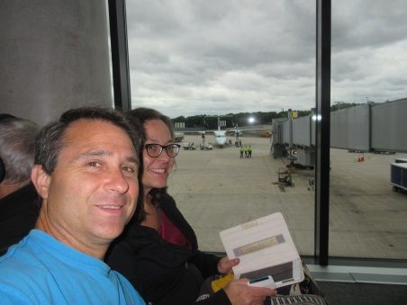
But that was not to be. After several lengthy delays, an airplane arrived and we boarded. We were well off-schedule by this time, but our connection in Montreal was such that we’d originally planned on a six-plus hour layover, so there was ultimately no problem. Once in Montreal, we had only a couple of hours before we were to board our more reasonably-sized jet to Iceland, so we found an establishment that wasn’t too crowded and had a seat at the bar, enjoying a couple of drinks, a snack and some conversation with other travelers.
Once on the airplane, it was quite late and we’d had a long day, so we slept for most of the way, waking just in time for breakfast. It was a reasonable fare, and with it we ordered some water and juice. Unfortunately, we did not think to order coffee for some reason unknown to me. Due to this oversight, we’d later suffer miserably until one of us realized the problem.
After landing on Saturday, September 22, 2018, going through customs and while awaiting our shuttle to the Icelandair Hotel Marina, I attempted to get some cash from the ATM using my Capital One 360 debit card, which is what we use on trips since there is no foreign transaction fee associated with it. I entered what I believed to be the proper PIN, and was rejected. I tried again after checking my documents as to the proper PIN and was again rejected. I then attempted a few of my regular 4-digit codes, and was summarily rejected and, when I was about to give up anyway, the machine ate my card.
Luckily, always prepared, I had with me a few hundred dollars of cold, hard American currency that I could turn in for Icelandic Krona (ISK), but would need, unfortunately, to incur a foreign currency transaction fee. I did this, we found our driver, and we were on our way to the capital, Reykjavik (the airport is located a little to the southwest in Keflavik).
The driver was quite informative regarding the capital and the surrounding four towns, indicating that most people on the island (250,000 of the total population of 350,000) reside in one of those five municipalities. The remainder of the populace is spread around the coast (for the most part) of the island which is about the size, in area, of Kentucky, within a few thousand square miles. Our driver hailed from one of the surrounding towns and mentioned that, although his town is often maligned by the residents of Reykjavik for being rather rough around the edges, it had lately begun a reversal of its image and was making strides toward respectability. This, to me, sounded like people talking about present-day Worcester, and I wished them well.
We arrived at the hotel too early for check-in, so were forced to bide our time in the lobby of the hotel along with some other unfortunates, all waiting patiently for room availability. Sue slept and I read. Once our room was prepared, we went up and promptly flopped on the bed and slept until around 9:30 PM, still feeling terrible, when I awoke with a start and finally realized what our problem was: NO COFFEE THAT DAY. I immediately made a cup for myself from the room coffee maker, and I believe that I offered one to Sue. After drinking the magic liquid, I felt better right away and had a nice night’s sleep, waking refreshed in the morning of Sunday, September 23, 2018 and ready for the included breakfast prior to heading out for our first day of adventure. Sue, I believe, was also much improved.
We went downstairs for breakfast and found that what was offered was a fabulous buffet that comprised many wonderful items that should be featured on every breakfast buffet worldwide: smoked salmon, tuna salad, sill, boiled eggs, stir-fry vegetables, scrambled eggs, Icelandic Skyr (a type of yogurt), all manner of nuts, grains and berries, oatmeal, cereals, juices, cod liver oil (with shot glasses!), milk and coffee. There were also plenty of options for all of you misguided meat lovers out there, but I will not detail any of that here or in any future buffet descriptions.
Our strategy throughout this adventure was to stuff ourselves silly during each morning’s included breakfast, then power right through to dinner without eating lunch. It worked quite well since during the interim times we were either driving or busy with a planned activity. On this, our first coherent morning in Iceland, we did just that. I am sure that I had at least five plates and/or bowls of various items, and Sue did the same. After a satisfying breakfast, we grabbed our belongings, checked out of the hotel and embarked on the first leg of our Icelandic road trip.
Actually it wasn’t quite that simple, though it should have been. We were scheduled for a pickup from the local Enterprise car rental office, where the driver was to have the hotel call up to our room and we’d then head down for our transfer. We received the call, grabbed our suitcases and went down to the lobby only to find out that the driver had left in a huff. The concierge called Enterprise on our behalf, and after forty-five minutes or so, another driver showed up and took us to the office. The office was somewhat understaffed and busy, so after another forty-five minutes or so, we had our car and were off. It was a six-speed manual fueled with diesel. I thought it quite nice and enjoyed the shifting of gears, a process that is not part of my daily life here in the USA.
For navigation, our car was equipped with a “Garmin” GPS device that took us a while to figure out, in addition to a well-marked paper map provided to us by our travel agents on the island, Nordic Visitor. They also gave us a cell phone for emergencies (and to contact their office) as well as a nice, personalized guidebook that contained all our vouchers for pre-paid activities and suggestions by Nordic Visitor staffers on other activities we may have wished to do along the way.
The first thing that we did after getting our car, however, was to stop by a 66° North store to purchase some excellent quality coats for our various adventures. They were a little pricey, but they really saved our bacon, so to speak, several times, especially while hiking the glaciers. After taking care of that business, we departed Reykjavik for our drive around Iceland.
Our first stop was The Cave People tour in Laugarvatn. We easily found the place using our paper map and were aided by the fact that there aren’t a whole lot of roads on Iceland. On the way over there on this, the first full day of autumn 2018, we noted that the landscape was covered in a light snow and it was frigid out. Back in Massachusetts it was much more, shall we say, seasonable. We truly didn’t expect this since we’d planned to visit the island during a time when we wouldn’t be missing the High Season at the YBH (summer), and when it would still be nice enough weather to be out-of-doors taking part in activities that we always try to do while away, such as hiking, caving and glacier tunneling. As I considered what the problem could possibly be, I made note of the fact that, at 66⁰ north latitude, we were around 24⁰ farther north than we are at the YBH. I thought to myself, “For comparison, where would we be if we were to go 24⁰ farther south of the YBH?” Doing some quick math, I came up with 18⁰ north latitude which is, as you probably know, well south of the Tropic of Cancer. Tropics –> YBH –> Iceland. That explained the trouble with our lightly-researched planning.
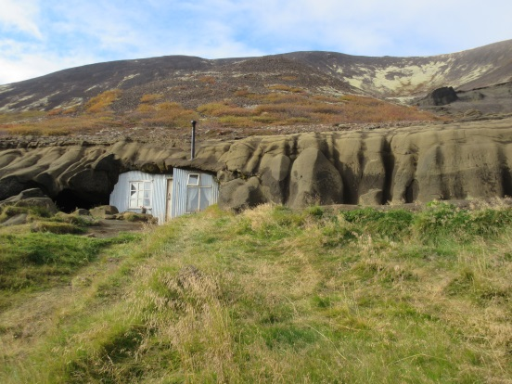
Our tour of the Laugarvatnshellar caves was scheduled for 1:40 PM, but we arrived a bit early. We parked in what appeared to be a parking area of sorts located adjacent to a tent containing a desk on one end and several tables set for diners on the other. We didn’t know ahead of time about this and wouldn’t have eaten there if we had since eating lunch wasn’t part of our plan (see above), but they serve lunch there. There was one other person waiting for a tour, surprisingly, so we joined her and were led up to the dwelling by our guide, who was wearing an example of what one would consider to be a typical Icelandic sweater. Sue didn’t think too much of it.
The tour was of a house that was constructed in a cave area of the hillside with three of its walls and its ceiling made up of rock. The floor was wood and there was a front wall made of wood, also. The living area is one room containing a small table, a couple of beds, some shelving and a stove. Dried sheep dung is used as fuel for heat and cooking, as it would have been when the place was occupied, which wasn’t all that long ago. Through a door in the back of the living area was a small, unlit “room” where the cow was kept. To the left of the living area and connected via a small opening with the cow’s room, was a small area in which around 100 sheep were kept during the winter months. The sheep provided warmth from their body heat as well as wool and food. Our guide is currently in the process of digging out the “floor” of the sheep’s area down a couple of feet so that people can comfortably walk into that area. The ultimate plan is to have the little café located in that area as opposed to the tent down below, but since he is the only one working on this project, I expect that it won’t be ready for several more years. We took a few photos, tipped the guide and left after spending around an hour or so there.
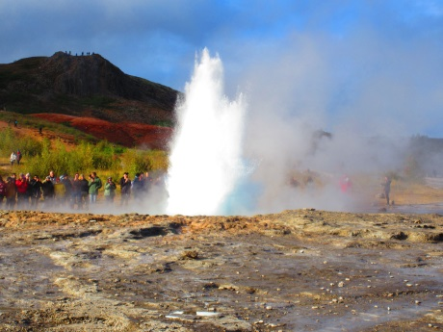
After the Cave People tour, we stopped at a geothermal area to see the Strokkur geyser that erupts every 10-15 minutes or so. We also saw a smaller one called the Litli Geysir (Little Geyser) on the walk to Strokkur. It wasn’t a planned activity, but it was suggested in our paperwork and was right on our route. This day wasn’t too jam-packed, so we had plenty of extra time.
Our next stop was a place called the Secret Lagoon in a small village called Flúŏir. We found the place easily enough using, once again, our paper map, and noted that, though it has the adjective “secret” right in its name, it evidently wasn’t that great of a secret; it was pretty crowded. We had to rent towels since we brought none, and they (thankfully) require that people shower prior to getting into the lagoon. There are separate dressing/shower rooms depending on one’s birth gender, so Sue and I split up to get prepared. We could have taken a couple of drinks into the lagoon with us but opted against that, although we were squarely in the minority in this regard.
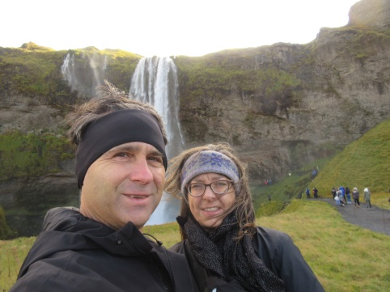
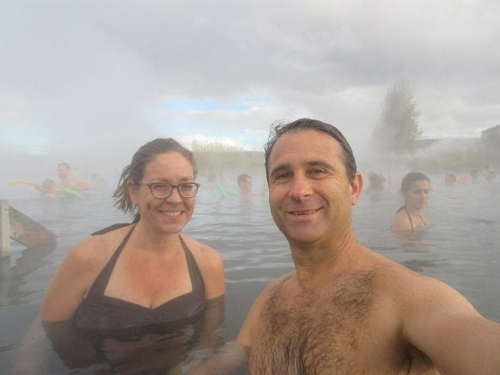
We met up outside and took a few pictures, then got into the water. The water in the Secret Lagoon maintains a temperature of 38-40° Celsius (100-104° F) all year and felt very nice in the chilly early autumn air. The water has a slight sulfur odor to it and the bottom of the pool is volcanic sand. Sue didn’t enjoy it at all and was “grossed out” by the natural floor and the slimy walls, but I didn’t mind it too much. According to our guide paperwork, we could see one of the geysers that we’d visited on the way to the lagoon, but we forgot to look for it through the heavy steam surrounding the lagoon. We spent around ½-hour in the pool, said to be the oldest swimming pool in Iceland, then went back to the changing rooms, showered, dressed and left for our hotel, the Hótel Selfoss in, appropriately, Selfoss. I arranged to have a “river view” room at the hotel, which was one of the normally-priced rooms. We ate dinner at the hotel, something that would become a regular practice throughout our trip since there are few dining options at most locations outside of Reykjavik, then retired to our room early to sleep.
The scheduled activities for Monday, September 24, 2018 were a tour at the Lava Centre Hvolsvŏllur followed by a Glacier Walk at Sólheimajökull, both included in our tour package. On the way to the Lava Centre, we stopped to see a very large waterfall called Efstadalsfjall. We hiked up pretty close to it, but it was very cold and windy and we didn’t want to get too wet, so unlike many other brave individuals that were there with us on that day, we did not go right up to the monster, enjoying its majesty from a little farther away.
The Lava Centre was an innocent-looking place with ample parking and many tourists. It was a modern building with a nice-looking café of which we again did not take advantage due to our plan to not eat lunches. We showed our voucher to the greeter, received our wrist bands allowing us access to the main exhibit, and embarked on the self-guided and self-paced tour. It turns out that the museum is located adjacent to a volcanically active field (much of Iceland is volcanically active). The tour is a series of interactive exhibits that give entertaining histories of the island and its volcanism, of the more famous historical eruptions, of the science underlying the various phenomena and of what it feels like to be nearby during some of the events. It is an entertaining and informative way in which to spend an hour or so. They also have a nice gift shop. After perusing the many and varied items in there, and purchasing a couple of them, we left to drive to our Glacier Walk, scheduled for 2:00 PM.
The description of the Glacier Walk reminded me of the description of a hike that we took in Bali a couple of years prior: a happy little walk onto a glacier to view the beauty, glory and majesty of the stark and striking landscape. Those weren’t the exact words, but I, at least, was expecting to hop onto the glacier from the visitor center, walk around for a bit, snap a few photos, and head out. This is not what happened. Incidentally, we needed to pay for parking for the Glacier Walk, which happened one more time on our drive.
Once in the visitor center, we needed to be fitted for crampons, but prior to that, our hiking shoes were rejected by the guides as inadequate, and they provided us with more rugged ones at no charge. We then were measured and fitted with some very serious-looking crampons and each given an ice ax to carry. We were both well bundled up for the hike and we set out for our three-hour adventure right on time with a group of around ten others plus our guide. The walk to the glacier took fifteen or twenty minutes along a dirt road, and we could see the “tongue” of the glacier onto which we’d be climbing. There were groups just coming down and others heading up, but the place was far from crowded since the glacier is quite large, and we didn’t experience any “traffic jams” like one would encounter while hiking Mount Everest, for example.
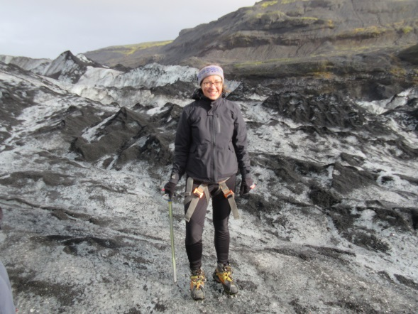
Our guide stopped us in a convenient area just prior to the tongue and instructed us on the proper method of strapping on our crampons. She was extremely knowledgeable and when asked, told us of all the rigorous training that each guide must go through before being allowed to lead groups on these treacherous hikes. She also pointed out a lake at the bottom of the tongue containing several icebergs that she warned was very cold and deep. She mentioned we shouldn’t get too close to it. Someone asked whether people swim in it during Iceland’s “warmer” months, to which she replied that she wasn’t aware of anyone doing so.
Once everyone had their crampons properly secured, she took us to the glacier, and told us that since we don’t get to go on glaciers every day, we should feel free to take as many photos as we’d like but warned us to make sure that we did not take them while walking as that could be quite dangerous. We only went a few steps onto the glacier when we came to a little crossing that had sheer drops of several tens of feet on either side and that was only a foot or so wide. As soon as I saw the thing, I started to panic and thought that I would just turn right around and head back to the visitor center. However, I closed my eyes, took a few breaths, and spoke sense to myself. After all, I merely needed to walk straight and trust my crampons and I’d be OK. Thankfully it worked out. It turns out that Sue was similarly worried but came to the same conclusion as I.
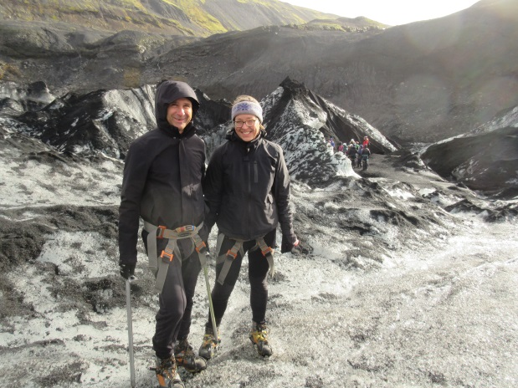
The crampons do an incredible job of sticking to the ice, but one must really stomp with each step and adopt a semi-marching gait, lifting one’s leg straight up by bending the knee and stomping straight down, all while keeping a six-to-eight-inch clearance between legs. Shuffling along is not allowed and would create a dangerous tripping hazard, and any rubbing of the foot against the opposite leg would result in torn pants due to the crampons’ sharpness. While on the glacier, we quickly became accustomed to this kind of walking and learned to have a great deal of faith and trust in the crampons. Use of the ice ax as an additional stabilization tool really aided us in the act of safely getting around the often-treacherous landscape. There were many crevasses and numerous times our guide would stop and point things out to us and scan for good routes, since safe routes constantly change due to shifting ice, melting, storms, new snow, etc. There were too many breathtaking vistas and sights to describe, each unique as far as we were concerned since there are few analogs to being atop a glacier in our everyday lives. Suffice it to say that our photos don’t do the actual views justice.
A word about the weather on the glacier is in order at this point. We each dressed in numerous layers: I had three layers on my lower extremity and five on my upper as well as two pairs of socks and two pairs of gloves. My outer layer on top was the rain/wind jacket I purchased at 66⁰ North, which was an invaluable asset. Sue was similarly outfitted. These outfits represented the proper way to dress. The weather was very cold, usually very windy, and alternating every five minutes or so between sunshine, blustery winds, driving snow, ice pellets and freezing rain. Over the three hours of our trek, we were part of so many weather changes we eventually became inured to them. Our guide, of course, was completely unfazed by any of it.
After a few hours hiking around the glacier, drinking glacier runoff (refreshing and delicious) and generally frolicking about this dangerous landscape, we made our way back down the tongue (thankfully not back the way we went up), removed our crampons, and returned to the visitor center. After turning in our crampons, ice ax and borrowed hiking shoes, we went back to our car for the short drive to our hotel for the evening: the Magma Hotel in Tunga.
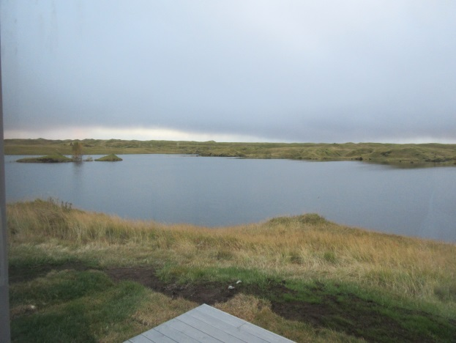
We’d reserved a very nice room at the hotel, which consisted of a series of stand-alone cabins. On check-in, we asked when dinner was served and were asked whether we’d made reservations, which we hadn’t. At that point, we were told we would not be able to eat at the hotel (outrageous, in my opinion, that a hotel guest would not be allowed to eat at the hotel). The owner told us that if we drove into “town,” there was a restaurant located there. We did so but didn’t like the look of the place and noticed a sign pointing to another hotel that had an associated restaurant: the Hotel Geirland. This was a lucky find since, as I previously mentioned, other establishments around many of our subsequent hotels were non-existent. After an excellent dinner we went back to our fabulous room, enjoying the view before going to bed.
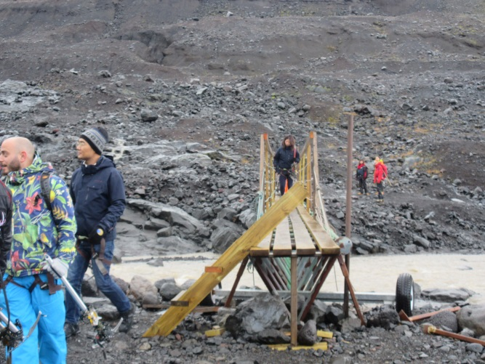
On Tuesday, September 25, 2018 we had another glacier walk scheduled called Blue Ice Experience at Skaftafell. We were scheduled for the 10:00 AM expedition and arrived by 9:30 AM or so. We were shuttled to the visitor center where we were fitted with crampons, given an ice ax and boarded a bus with fifteen or so others for our guided tour on the Skaftafell glacier. This was a similar experience in many ways to the previous day’s hike, but there were a couple of differences. On the hike to the glacier, we needed to cross a bridge that was constructed in such a way that the guides were comfortable allowing only three people at a time to cross. I wasn’t particularly happy about this, wondering how they came to the conclusion that would be a “safe” number of people, but I complied and went over. Also, having just done this the day before, both Sue and I were far more confident that we’d be able to safely traverse the glacier.
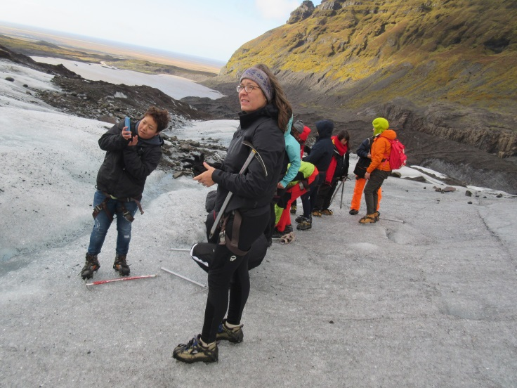
The weather was similar to the weather atop the glacier the previous day, but there were more crevasses, it seemed, and a couple of ice caves that we were able to explore. Also, as the name of the hike suggests, the ice had a distinctly blue tint here caused, we were told, by the density of the ice on this glacier and the resulting refracting of light as in the sky to the shorter, bluer wavelengths. It was quite a striking effect. There was an opportunity to taste some of the glacier ice, but it was presented on the end of an ice ax, so I declined. I’d tasted runoff directly from the stream the previous day, so was satisfied that I could imagine how the ice would compare.
Some individuals chose, evidently, a different hiking package than did we, because they seemed to be hiking the ice falls located far in the distance from where we stopped around two hours in. I would have been very, very unhappy hiking there and was glad that we chose the three-hour option. After a few photos, we all were guided back down the glacier to the waiting bus that shuttled us back to the visitor center. We turned in our crampons and ice ax (these people allowed us to use our own hiking shoes), and we were on our way.
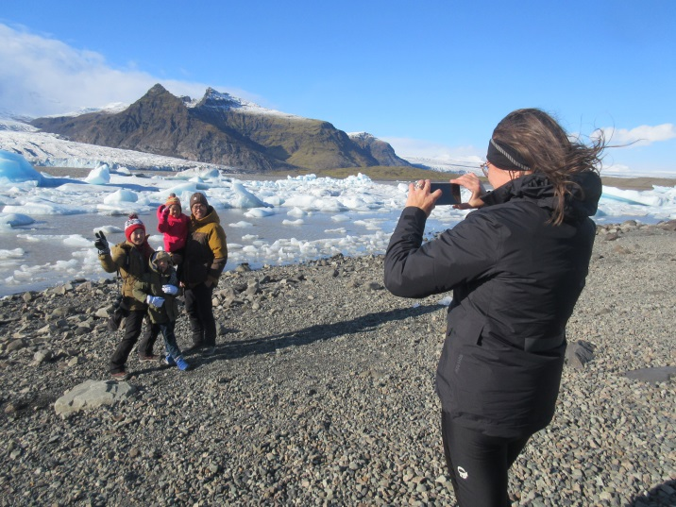
We didn’t get too far when we came upon another suggested stop called the Jökulsárlón Glacier Lagoon, which was featured in some well-known films: Tomb Raider, Batman Begins, A View to a Kill and Die Another Day. It was a breathtaking view, and Sue kindly agreed to photograph a nice-looking family in front of the scenery. (We’d see this family again at our next stop while waiting for our boat ride to begin.) We had to hike a little distance to this area, but it was well worth it, even in the wind and the biting cold.
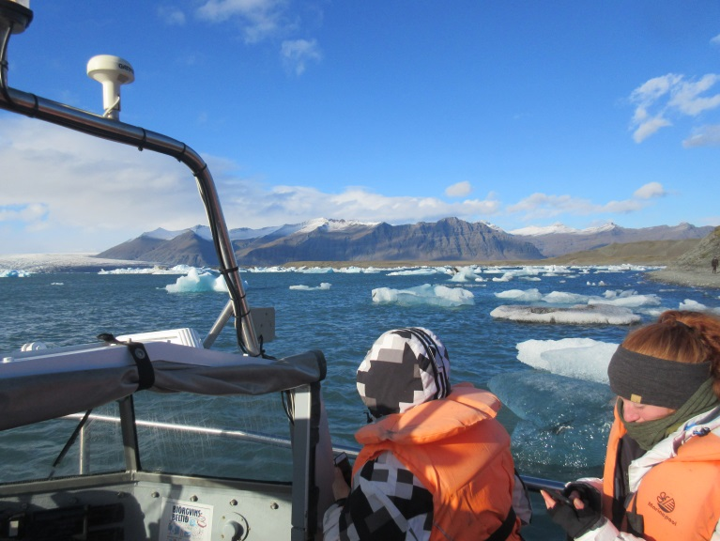
Following that lagoon, our next stop was called “Boat Ride at Jökulsárlón.” We were a little bit early for our scheduled tour, so we wandered around the property for a little while, seeing the family that Sue photographed at our previous stop. They didn’t seem to take note of us, and we didn’t interact. The tour itself took place in an amphibious boat much like the Duck Boat in Boston, except this one plunges directly into a Glacier Lagoon at Jökulsárlón, motoring right up to some glaciers and riding right by many others. Our native guide was seemingly unaware of the extremely cold, at times gale-force wind on this otherwise mercifully sunny day, wearing his jacket open, no hat and no gloves. At one point, one of his compatriots drove up alongside of us in a speed boat with a very large chunk of glacier ice, handing it over to him. Our guide held it as if it were a baby, right in his bare hands while explaining about the glacier-forming process, how the icebergs calf and how pure the ice is. He then shaved off some of the ice onto a tray, bringing it around the boat so that the bundled up, shivering tourists could try some of it. I passed on the opportunity, not thinking the whole affair was very sanitary and having already tried glacier runoff. After driving around the lake for a little while longer, we went back ashore and got into our nice, warm car to head to our next hotel: the Fosshótel Vatnajökull in Hornafjordur.
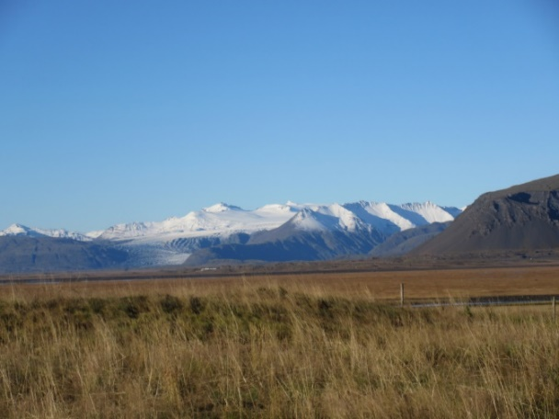
Navigation to the Fosshótel was accomplished, once again, by use of the paper map since we hadn’t quite figured the Garmin unit out as yet (we’d do so over the next day or two). This hotel is located fairly close to the glacier Vatnajökull, hence its name, and in fact the glacier can be seen from the location, although not the specific tongue on which we’d hiked that day. It was right off of the highway, so was fairly easy to find, but we were both pretty tired since we’d packed several activities into the day. We made dinner reservations for the excellent restaurant during check-in and deposited our bags in our room. We like to eat early, so as I recall, we cleaned up and put some nice clothes on and went right to dinner.
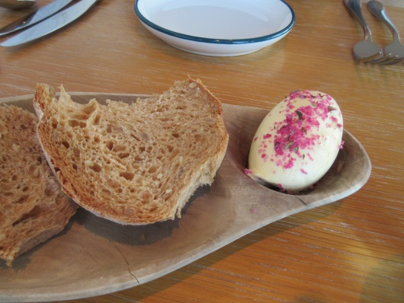
I won’t normally mention specific items we ate, but one of note was the beet-salted butter to go on their homemade whole grain bread, which we ate way, way too much of. Next time, I think I’d ask for two of those and just eat the butter plain.
During this drive, we would be traveling in-and-out of the eastern fjords for a good part of the day. While extremely and breathtakingly beautiful, they make for a very long drive up the eastern coast. Was it worth it for us as tourists? Of course, but I wouldn’t want to commute to work that way each day. And I’d imagine that during the more wintry months these roads would be downright perilous. As it was, there were times that Sue was less than happy on some of the cliffs and going through miles of tunnels. We stopped several times to take photos, which don’t do the actual scenery justice, and we knew they wouldn’t, but we couldn’t help it.
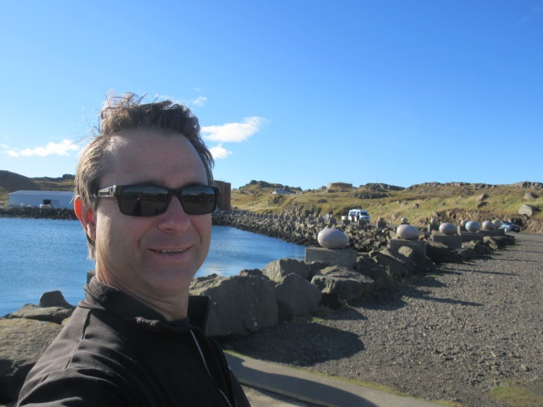
On Wednesday, September 26, 2018, we didn’t have too much planned regarding included activities; just the Myvatn Nature Baths, located pretty close to our hotel, so we decided to make a couple of stops at some recommended, optional activities. The first stop was at a silly attraction called “Eggs of Merry Bay” in a tiny town called Djúpivogur. The town is located at the mouth of Berufjörður fjord. The town itself is pretty old, dating to the 16th century, and signage is terrible, but we stumbled across the attraction regardless. It is located in a run-down shipping area and consists of 34 granite eggs that represent various local bird species. Each oversized egg is on its own separate pedestal along the water’s edge and the entire sculpture is the brainchild of local artist Sigurður Guðmundsson. We spent five or ten minutes looking at these egg sculptures, each of which has an associated explanatory plaque, then went on our way to the next attraction.
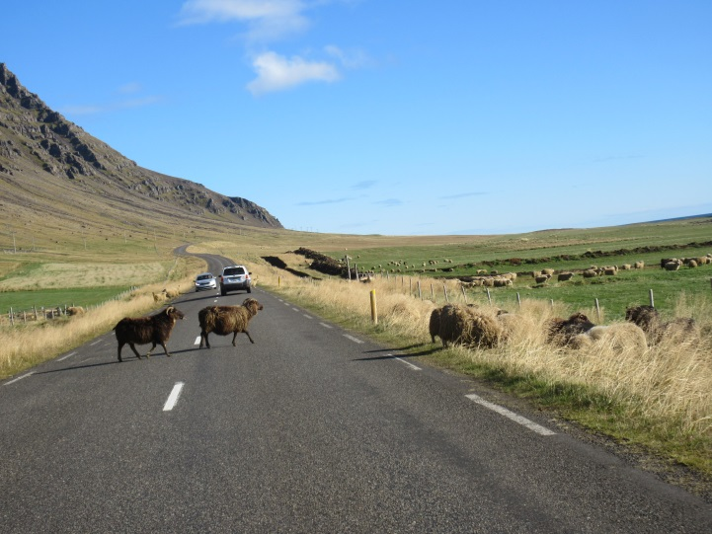
Our easy drive was interrupted by a herd of sheep that commandeered the road in a remote farming area. The animals have the right-of-way, so we needed to patiently wait for them to cross the road and re-take the fields. After a few minutes, they cleared out and we were able to proceed. One or two other cars also needed to wait, and it was nice that, for all that time, no one beeped their horns even once.
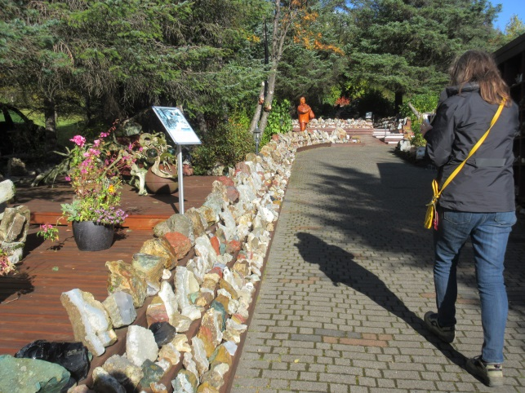
Our next optional activity stop was at Petra’s Stone Collection, billed as the most popular tourist attraction in eastern Iceland. It’s located in Stöðvarfjörður, and the stones were collected mostly by Petra Sveinsdóttir. She collected for over 70 years, and the mineral collection is now one of the largest of its kind in the world. They’re mostly local minerals and rocks that she collected on excursions into the surrounding mountains. The gardens and displays are quite interesting, and I expect that not many places like this exist in the world. This was a good stop; I’m glad that we took the time to go there. Petra is now deceased, but her children still maintain the property and museum, which was also interesting. It seems that, in addition to stones, Petra collected just about anything that she saw: pencils, handkerchiefs, eggs, bones, shells, playing cards, stuffed birds, fowl, animals, matches, etc. This is well worth the time and entrance fee if you ever find yourself looking for something to do while in eastern Iceland.
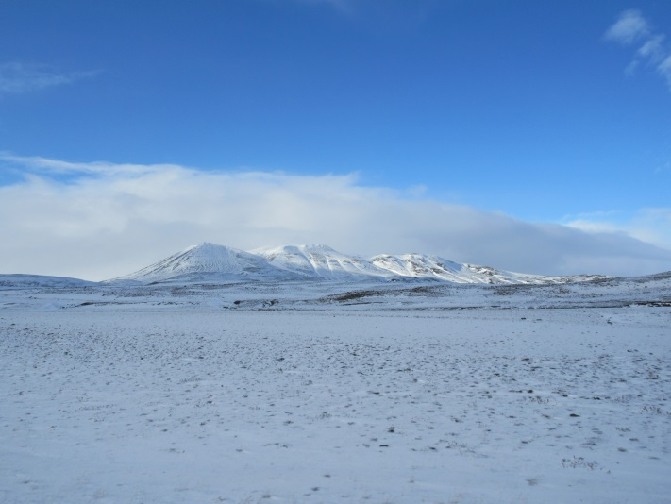
After trips around another fjord or two and tunnels through a mountain or two, we traveled over a mountainous area that was snow-covered. We went through a small snow squall, but since there is no traffic, and since we were traveling at a reasonable speed for the conditions, we had no trouble. The quickly-changing weather, though, is something of which one must be mindful while driving in Iceland.
Our final detour of the day was to the Dettifoss waterfall, the most powerful waterfall in Europe. I tried out the movie-making feature of my camera in an attempt to capture it, and so did Sue on her i-product. It was a pretty long hike in (I think it was a mile or so), but it was worth the time and effort. Lots of other tourists were at this attraction, but I wondered here, and at several other stops, how so many tourists come to be at these spots when we meet almost no one on the roads.
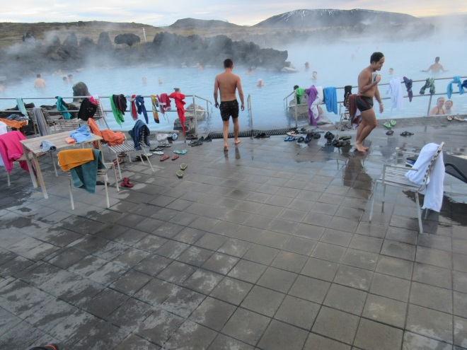
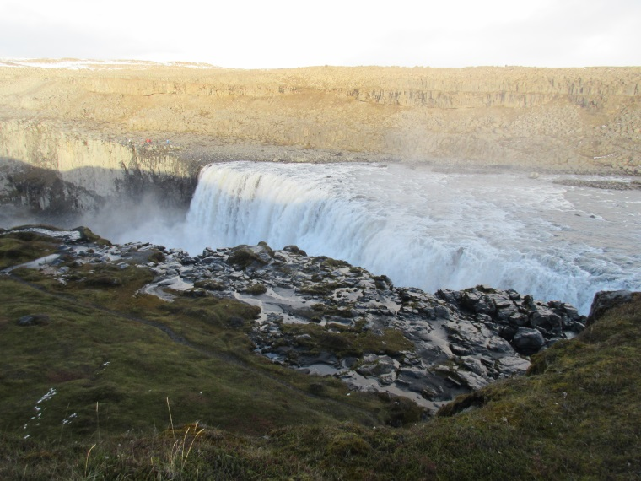
Our included activity for the day was the Mývatn Nature Baths. We decided to go there prior to checking into our hotel because we’d have to backtrack quite a distance if we checked in first, and I’d done quite a good deal of driving already. This place was more modern than the Secret Lagoon, but it was along the same idea: separate dressing rooms, showers, followed by a nice soak. The bottom of this lagoon wasn’t the volcanic sand as in the Secret Lagoon; there were some non-slip mats and other artificial materials. It seemed a bit less rustic, but still had a rather strong sulfur scent to it, which doesn’t bother me at all, but Sue was upset by it. We stayed in the bath for around 30 minutes or so, then showered off and went to the hotel.
Before checking into the Hótel Laxá, we had to find it, which proved to be no small feat. As yet, we’d not become very comfortable with our friend Garmin, so we relied for navigation on our map, which amounted to Sue interpreting where we were, determining appropriate side roads, and letting me know whether to turn left or right, onto which numbered road and in how many kilometers. That normally worked pretty well, since there really were not too many roads on the island and signage, at least on the more main roads, was generally decent. For this hotel, it looked from the map as if we’d need to take a left off of Route 1 onto Route 848, and then in a little while we’d need to take another left onto Route 849, where we’d find the hotel. All of this looked much clearer on the map than it did in reality and we did a great deal of backtracking and experimenting before we stumbled on the hotel. It was in the Lake Mývatn section of northern Iceland and featured what were referred to as “lunar landscapes.” We’d be spending the next two evenings at this hotel, which was fine with us because we’d been doing an awful lot of running around for the previous few days.
We checked in and made reservations immediately for dinner, went to our rooms, changed and went to the dining room for our meal. The meal followed the pattern of being excellent and relatively pricey. I believe this was the evening that we were awakened by a call from the front desk indicating that the Northern Lights were visible and heard people in the halls excitedly rushing out to see the Aurora Borealis, but it may have been the following evening. Regardless, the light show was as spectacular as you’ve probably heard, and Sue enjoyed it for a little longer than did I.
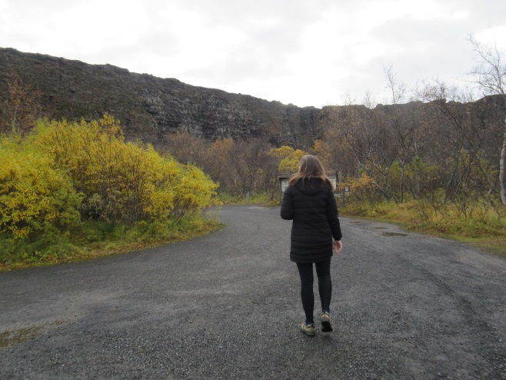
After an excellent night’s sleep and breakfast, we set out on Thursday, September 27, 2018 for our day’s drive and activities. The big plan on this date was a whale watching tour, but that wasn’t set to leave until 11:30 AM. There were a few optional activities, though, including a horseshoe-shaped canyon called Ásbyrgi. There is an origin legend associated with the canyon that Odin’s flying horse, Sleipnir, accidentally touched one of its hooves onto the earth during a joy ride, however this explanation has since been refuted by humorless geologists, who insist that two massive floods from Vatnajökull glacier are more-likely responsible. They claim that the first occurred around 10,000 years ago and the second around 3,000 years ago. Sue and I had an enjoyable hike into the canyon, going all the way to the end where there is a nice little lake with a couple of viewing areas, a small waterfall coming out of the rocks and some great, informative signs giving explanations of all of the flora and fauna indigenous to the area. On the walk back to our car, we decided to take the scenic route through thicker growth areas that told us even more about the flora around that area. All of it, luckily, is specially adapted to survive in colder climates.
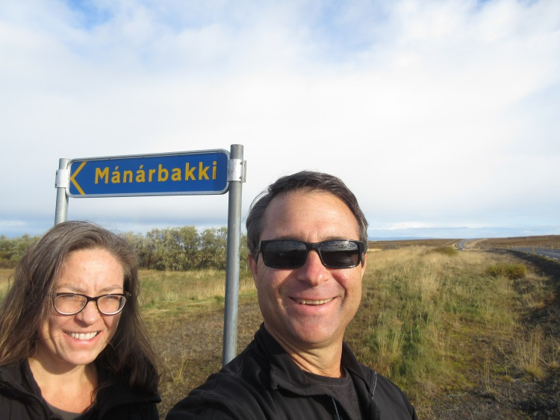
The canyon was beyond, by a good, long drive, the village from which we’d be embarking on our whale watching expedition, so we backtracked at this point, making only one stop along the way. On looking at the map, Sue noticed that we’d be going past a point (twice, as it turns out) that is the northernmost that either one of us had been to that point in our lives. The small (and I mean small) village of Mánárbakki, based on the map provided and by performance of a quick calculation, appears to be at about 66°12’ N Latitude, just a few arcminutes from the Arctic Circle (none of Iceland quite touches the Arctic Circle). Obviously, we stopped to take a photo there. (Our drive on 9/28 would take us to a point in Sauòares just slightly more than an arcminute below this, but that wasn’t nearly as exciting.)
Húsavík Harbor in the village of Húsavík is where North Sailing, the company that runs the whale watching expedition that we’d be taking, is located. We stopped at their store-front property to get directions to their recommended parking area and parked our car. We decided that a quick stop in a store to purchase a nice hat and some gloves was in order, so we did that. We didn’t realize that North Sailing had a variety of 66° North clothing in their store, a lucky bit of ignorance that saved me at least $150. We stopped by the front desk, retrieved our tickets and went down to the docks to get our outer cold weather gear. The guy at the desk mentioned that we should put on “all of the clothes that we brought with us to Iceland to keep warm” in addition to the extreme cold weather suits we’d be issued at the docks. We, for the most part, did this, dressing as if we were heading up onto another glacier. This harbor is located in the northern North Atlantic, just a bit south of the Greenland Sea and the Arctic Ocean, so the advice turned out to be excellent and appropriate.
We retrieved our extreme cold weather gear and made our way to the whale watching boat. There were a total of around twenty-five people in addition to the crew. We donned our suits and waited for the departure sitting near the stern. On the way out of the harbor into the North Atlantic, our guide said, with not a hint of guile, that we were fortunate on this day because the ocean was so calm (the swells were, in my estimation, five to six feet). She then went on to let us know about calling out whale sightings, with the bow of the ship always at 12:00, starboard 3:00, stern 6:00 and port 9:00. She then told us that in the hopefully unlikely event that one of us were to go overboard, others should shout and point so that the ship could come about quickly for a rescue since she estimated we’d survive for around thirty seconds or so in the water.
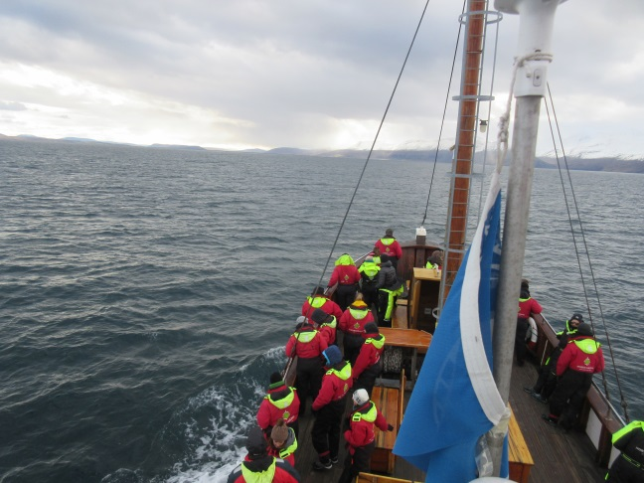
Sue and I started out on the deck, but eventually made our way to the observation area (not the crow’s nest, but the place just below that). I always get a bit queasy on a ship, and this day was no exception, and it is a great help being above the water so that I have a clear view of the horizon. We witnessed numerous whales, probably around a dozen or so, all humpbacks. We were able to get pretty close to around five of them, but it was difficult to get great photos due to the movements of the boat and of the whales. All the while, our extreme cold weather gear and other clothing kept us pretty comfortable. Just as I was thinking that it would be nice to start heading back in, that’s what we did. Along the way, the crew brought out some cinnamon buns and hot chocolate for everyone, which neither Sue nor I took. As we entered the mouth of the harbor, we took our extreme cold weather suits off, at which point we realized how great a job they’d been doing for us.
We left the boat and decided to eat our dinner at a local restaurant. The hotel dinner on the previous evening was very nice, but there were limited menu choices for us, and we thought that a local restaurant at the village would be a welcome change since the option was available to us. The restaurant that we chose, called Salka Restaurant, was quite cozy and cost about half what we’d have paid at the hotel. After dinner, we found, with some difficulty, a state-run liquor store in town and picked up a couple of box-of-wines for our trip, to try to save some more money. Back in our room, we watched a little local television, had a glass of wine and went to bed early since the following day would entail a great deal of driving.
On Friday, September 28, 2018, after another typically excellent breakfast, we’d be heading farther to the west traveling over a few more of the northern fjords. At this point in the trip, Sue did some calculations on driving distances, times and scheduled events and noticed a problem. Our total drive mileage for the day was pretty high; she estimated it to be around 330 km (200 miles or so). This in itself isn’t a huge problem since it represents around four or five hours of driving. However, we had a scheduled activity – Couple’s Bath with Bjórböðin (The Beer Spa) – that was scheduled for 5:00 PM, and was located in a town called Árskógssandur very near to our starting point, the Hótel Laxá. Doing some quick math, we realized that would put us arriving at our next hotel sometime after 10:00 PM with no stops and no dinner, assuming excellent weather and road conditions. This would obviously not work for us. I called the good people (but terrible schedulers) at the Nordic Visitor center and had them change our Couple’s Bath to a more reasonable 11:30 AM. This they did, and we headed to the Beer Spa from our hotel giving ourselves plenty of time to make a stop along the way.
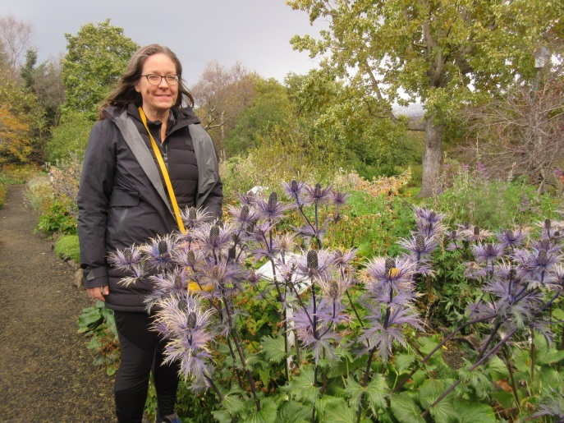
Sue wanted to see the world’s most northerly botanical garden located in the town of Akureyri. We stopped at the main tourist center in town to get a “parking-clock”, which is a small paper device on which one sets the time that one arrives in a parking area and places it on the dashboard. Many of the more in-demand lots have time restrictions ranging from fifteen minutes to several hours. The lot for the botanical garden, it turns out, was not a lot in high demand, so there was not a time restriction. We nonetheless put the parking-clock on our dash, just in case, since we didn’t wish to be stranded in Akureyri.
After a little searching around the perimeter of the lot, we found the gardens by following a somewhat hidden path located adjacent to it. The location of the path wasn’t obvious since there were not any signs pointing the way, and the parking area was shared with several buildings that could have been offices or apartments or both. We walked along the path, eventually encountering signs welcoming us, explaining the botanical garden layout both in text and graphically, and pointing the way to various attractions. We were right up against the off season even though it was very early autumn and, no doubt, quite pleasant back home (albeit exceptionally rainy, as it turns out). The weather in northern Iceland that day was overcast, breezy and chilly but dry, and during our walk around the grounds we noted that the peak season for the garden was past, but there were still plenty of nice blooms and greenery to be seen. There were a few other individuals wandering about the grounds, but we had no trouble stopping to admire or read about the flora at will.
We spent around one hour total in Akureyri and made our way back out the main “highway” and resumed our drive to Árskógssandur for our Couples Bath at the Beer Spa. As we neared the location where the town was shown on our map, we kept our eyes open for any indications of the Beer Spa’s existence. We saw a sign for it that could have said “The Beer Spa – 2 km” or something similar and kept looking. We went by a road on the right that indicated nothing and after another couple of kilometers, decided that must have been the road for which we were looking. We turned around (right in the road since there was no traffic) and headed back, again seeing a sign for the Beer Spa. We took the previously-mentioned unmarked road, carefully obeying the ever-more-slow speed limits and approached a run-down looking town of maybe twenty or thirty houses, a shipyard and not much else. The town was located on the water between a couple of the northern fjords, so the view was quite nice, but we didn’t see a spa anywhere. I just kept driving past the shipyard and we came upon a building that had a small sign on it that said “Beer Spa and Restaurant.”
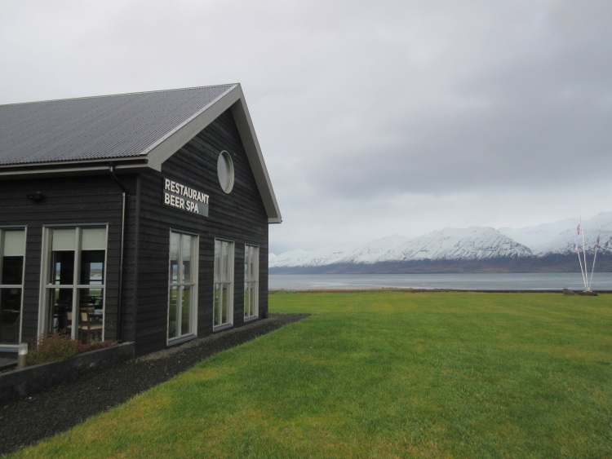
We were about fifteen minutes too early for our appointment, but went inside nonetheless (there were no other cars in the lot). I apologized to the attendant for our early arrival but she assured us that it was fine and that they’d need several minutes to prepare the Couple’s Bath. After about ten minutes, she came out and beckoned us to the back. She told us to strip down and don some robes, letting us know that bathing suits were completely unnecessary since the bath is private, which was fine with us. After putting on our robes and meeting back up outside the changing rooms, we were led to a small room with the spa in it. The room also had a keg, two cups and a shower-looking device. Our instructions were that we could drink as much beer as we wanted during our 25-minute soak but we could not take any outside of the room afterwards (Sue had four large-ish cups, I had two (I was driving)), and we were not to use the shower device under any circumstances since that was the wand they use while cleaning the spa after use.
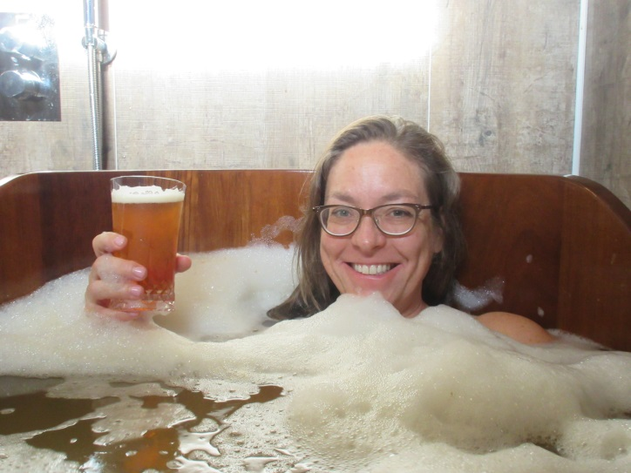
The instructions were quite simple, we had no questions, and we were ready to begin. The “beer” in which one soaks is taken from the brewing process fairly early on. It has a faint beer odor and feels very, very nice on one’s skin. We luxuriated in this while enjoying our beers and each other’s company, then all too soon, we were told that our time was up. We climbed out of the spa, toweled off and donned our robes again, heading back out to the meeting area outside of the dressing rooms. At this point, we were led upstairs to a large room with many lounge chairs. The attendant brought us to two chairs in a far corner and bade us sit down, which we did. She then covered us with a blanket, massaging our feet and tucking them into the blanket. It was dark in there with calming music playing. Here we stayed for another twenty-five minutes or so, after which we were brought back downstairs to the changing rooms, where we changed and made our way back out to the car.
At that point I told Sue that, if there were such a place near the YBH, I’d go there every week. This was definitely a highlight of the trip for me, and I highly recommend it to you (the reader) if ever you find yourself in northern Iceland. Even if you have something else to do in northern Iceland, cancel that and do this.
There were a few suggestions for additional stops, but the drive ahead of us was still quite long and we decided to get closer to our hotel and decide whether we wanted any additional stops that day. It turns out that some of the roads were questionable, at best, and took longer to navigate than we’d estimated, so we didn’t stop anywhere else, eventually arriving at the Hótel Laugarbakki just a short time before dinner.
We navigated to the Hótel Laugarbakki by using the paper map provided by the Nordic Visitor folks, but were a little worried when we drove onto the road indicated and there were just some run-down farm buildings and a few other small shacks. The road itself was gated and one-lane, and initially we thought that there was a good chance we’d taken a wrong turn somewhere. It turns out that we hadn’t. At the end of the road was a very small sign (I should have taken a photo of it) pointing to an odd, institutional-looking building and indicating that that building was, in fact, the Hótel Laugarbakki. We drove up to the place, parked in a gravel lot and checked into our standard room. Since we were there for only one evening, I saw no need to upgrade. We made dinner reservations while checking in (there were most definitely no other restaurants in the area) and went up to our room, which incidentally was in another portion of the complex requiring us to exit the hotel’s main lobby and enter through another door. Dinner was very nice (as was the case everywhere), and surprisingly relatively inexpensive, and we went to bed fairly early because we were pretty exhausted from all of the day’s activities and the long drive.
We awoke early on Saturday, September 29, 2018 ready for another long drive to the Snӕfellsnes Peninsula in western Iceland. The Nordic Visitor people mentioned a few suggested detours, but the roads, once again, weren’t the best and the drive took us quite a long time. We did, nonetheless, decide to stop at the Bjarnarhöfn Shark Museum, because it intrigued us. It turned out to be nothing like we expected from its name, and I wonder whether any of the Nordic Visitor people had ever gone to it. There was a small sign pointing down a long road right off of the main road, so we found the place with no problem. The museum itself was located several km down the small road, and it took us about ten minutes to get there from the main road. We came upon a village consisting of no more than a few structures, one of which was a house and one the museum. This was a museum unlike any I’ve visited.
We parked and there was a sign-board by the front door of the unassuming building that said “Come In and Taste the Shark and See How It’s Made.” At this point, we should have returned to our car and headed for the hills, as they say, but we didn’t. We went inside, paid our admission cost (USD $21.61) and went into the museum. There was a tour (museum staff and a young couple) ahead of us, but it was nearly finished, so we were told we could look around. The museum had one of the oddest assortments of collections that I’d ever seen, but very little in the way of shark. There were fishing boats, old motors, a tractor, stuffed animals (not the toy variety), eggs, old adding machines, old typewriters, old books, old fishing gear and clothing, etc. There was a booklet talking about various types of sea life, including sharks, and some dried or salted edibles that did not, frankly, look like anything I’d wish to purchase.
Eventually, the couple ahead of us was led to a table where they tasted the shark, called Kӕstur hákari which is Icelandic for “fermented shark.” The couple was not close enough to us for us to get a good indication of their reaction. Once they left, the person that collected our admission fee came to us and said he’d now begin our presentation. He brought us over to a couple of chairs located in front of a television screen, told us that photographs of the presentation were not allowed, and started the DVD playing. It told of how the Greenland Shark, the source of the fermented shark meat, can attain ages of 300 to 400 years, how this is the type of shark traditionally hunted in those parts, how the shark is brought back to the peninsula, and the process of curing the meat for consumption. Our guide narrated while the video played, and he often stopped and smiled at us, seemingly expecting a reaction or a question. I was flabbergasted at what we were watching, having expected more of a general shark theme. However, when our host was explaining about burying the thick slabs of shark meat for three months, then hanging them outside for another nine months to cure, I did ask a question or two, one of which was what would prevent bugs or microbes from eating the meat and making is otherwise spoil. He thought this was a very good question, explaining that while buried, the meat forms a rather thick outer layer. He then said that regardless, since the shark has no way of expelling urea, the poison pervades the meat, rendering it completely unpalatable to all life forms save for one specialized microbe that breaks down the urea (mostly) into an ammonia compound that isn’t quite as poisonous as the original urea. So there was that to help protect it from spoiling. And since there are no insects on Iceland, the curing meat won’t attract flies or other flying pests.
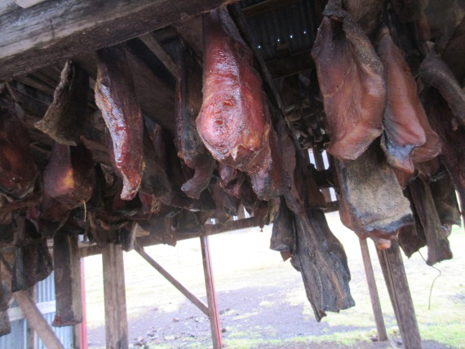
Sue asked whether the meat could be considered a health food, and he said that, in fact, it is one of the healthiest things that one can eat, and that he loves it. She then asked if they have a steak-sized portion at a meal and he laughed saying that, while it is very, very healthy, if one eats too much of it at once, one will die since the liver and kidneys would shut down due to all of the poison in it. The locals, therefore, will have just small amounts of it, normally with a small bit of strong, brown bread. Then he asked if we’d like to try some. I’m not sure why we did, but we made our way to the table where the previous couple tried the carefully-cured shark meat. There was a small container of little squares of shark meat and another container of small squares of the dark bread. I stacked one on top of the other and popped the construction into my mouth, much to my mouth’s displeasure. Sue did the same. After we swallowed the vile stuff, Sue asked what that odd flavor was, and our host said that it was ammonia. She then decided to try some without the bread (I did not, since I was already questioning my sanity at this point), and she instantly rued her decision. After a few tentative chews, Sue spit the meat into a napkin and threw it away. We thanked our host and got the Sam Hill out of that place.
Our accommodation for the evening was the Hótel Búðir. Once again, however, Sue noticed that our first scheduled activity on the following day (9/30/18) was located around 25 km BEFORE we’d get to the hotel, so again I called our friends at Nordic Visitor to change that activity to 9/29 so that we could do that on the way to the hotel and not the next morning. I didn’t have any desire to add 50 km to the next day’s long drive by backtracking, and Sue agreed. The travel agent that we spoke with changed our reservations for the Vatnshellir Cave Exploration so that we could stop on the way, and while we were at it, we changed the following day’s “Into the Glacier” tour from 3:00 PM to the earliest possible, which, if I recall correctly, was 10:30 AM or so. The latter tour was a three to four hour tour, and the drive after the tour ends was going to take around three hours. Like I mentioned previously, there is some terrible scheduling over at Nordic Visitor. They changed everything to our liking, and we stopped at Cave Vatnshellir for our cave exploration tour, which was set to last around 45 minutes.
Sue made the mistake of doing some reading about the cave exploration online and decided that, even though the tour was pre-paid, she was not going down into the lava tubes. When we arrived at the visitor center at the Vatnshellir Cave Exploration area, we handed over our vouchers, explained that we were there a day early, and made sure it was alright to join a group. I also explained that, although we paid for two vouchers, only I would be going on the tour. The people running the place had no problem at all with any of that, so I was outfitted with a helmet and flashlight. I was well-dressed for the cool dampness of underground, so once the whole group was ready, we made our way with two guides to the entrance.
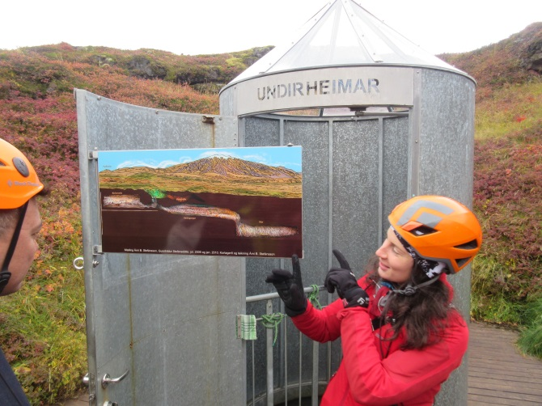
The guides split the group into two, one going with the male and the other group with the female. I went with the female. Prior to going into the caves, we had a discussion sky-side letting us know what to expect, how the caves were formed and a bit of history of the area. Sue was present for this portion of the tour. Our group was first, so we went through a door located within a top-of-missile-looking structure that contained only the hole and a spiral staircase that allowed access to the lava tubes for only one relatively slim person at a time. Our instructions were to get to the bottom of the staircase and to regroup in a certain area there where we’d await further instructions. This we did.
The guide then informed us about the caves, the temperature, how to move about, what comprised the walls and what to expect as we made our way around. She then brought us deeper into the cave where we encountered another similar, but much taller spiral staircase than the first. This one went very deep into the earth, again allowing only one person at a time. We got to the bottom of that and went deeper into the cave horizontally. At this point, there was no outside light (so no light), no outside noises and it was cold but bearable since there was also no wind. The caves are old lava tubes, no longer active (we were happy to hear), that were formed thousands of years ago. The walls were very rough, causing the effect that there is no echo whatsoever. Our guide had us all scream and then stop abruptly. Sure enough, there was just dead quiet immediately. This was a very unusual effect; one with which none of us was familiar previously, and you wouldn’t be either.
She then had us all shut off all sources of light. Sure enough, again, there was total darkness, another effect with which we, as humans, were thoroughly and surprisingly unfamiliar. At this point, the guide mentioned the fact that the only animals that are ever seen down there are the occasional lambs that tragically fall into one of the sinkholes and drop down to the cavern floor (I would assume hurt pretty badly, but no one brought this up). She claimed that the unfortunate animals would wander about until they starved since nothing but one specially-adapted fungus grows down there, presumably not nutritious or plentiful enough to sustain life. One of the individuals in our group asked about bats, but the guide said that there are first of all, no bats on Iceland, and second, they wouldn’t be able to get along down there regardless because their sonar would not work (no sound reflection off of the walls or any other surfaces).
After a little more wandering around, and the guide pointing out a few of the formations and lore surrounding them, we started making our way back out the way we came in. We needed, at one point, to pull over to allow the other group access since the walkways are quite narrow. I was happy to get back topside but also quite enjoyed the experience and would do it again. I think that Sue would have enjoyed it, too, but she insists that she made the correct decision for her.
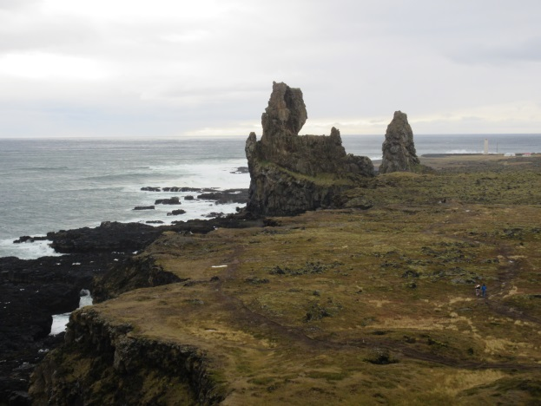
After leaving the Vatnshellir Cave parking lot, we decided to make one stop very nearby to view a special rock formation that was on the side of the road. The rock formation is called the Lóndrangar Basalt Cliffs in Hellnar, and the cliffs feature a pair of volcanic plugs of basalt that remain after the surrounding, softer rock was eroded away over the millennia. We hiked up the short distance from the moderately full parking area to the viewing point, snapped a few photos and continued on our way.
It looked as if the Hótel Búðir would be pretty easy to find from here. There wasn’t much on this peninsula, especially on the southern side of it. We estimated the distance, checked the odometer and confidently headed out. After traveling approximately the distance that we decided was correct, we started looking for signs. There were no signs of structures on either side of the road as far as the eye could see, but we noticed a small sign coming up in the near distance. As we drove past it and past the small road on which it was located, we noticed that it said Búðir. I don’t remember an arrow, and the sign itself was just a few inches wide and maybe a foot long on a four or five foot post.
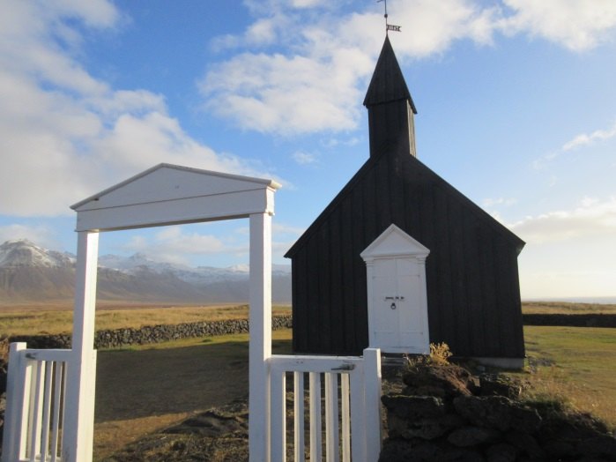
I said to Sue “That must be it!” to which she replied that it didn’t look like there was anything down that road. But I made the point that, logically, how many signs for Búðir were we realistically likely to encounter? The answer to this question, of course, was “one.” So I turned the car around, again in the road since there was no traffic, and we headed back to the road with the sign. We drove quite a little distance down the road to Búðir and eventually came to a building on our left (no signage whatsoever), and up ahead, just past the building, a church with an associated cemetery. We thought that the hotel was probably just beyond the church over the hill, but alas, the road ended at the churchyard, which was atop a small hill. I stopped the car, got out and looked around, seeing no other buildings save for the one we passed and the church; no houses, barns or municipal buildings of any kind. So I said to Sue that the building that we passed must, by the simple process of elimination, be the Hótel Búðir, so we went down the small hill and parked in front of the building. We went inside and found that there was a front desk and that this was the Hótel Búðir after all. After checking in and making the earliest possible reservations for dinner, we went up to our room to look around. It was a great room: big, comfortable, well-appointed and with a nice view. I noticed an ironing board, to my delight, but no iron, so I went down to the front desk to ask about this odd arrangement. The front desk clerk, who may very well have been the owner, went in back to fetch an iron for me, and I made my happy way back up the stairs to our room to do some much-needed ironing of my shirts.
Following this activity, Sue and I decided to go down to the beautiful lounge and have a small something. Sue had a glass of white wine, no doubt, and I decided on a finger of whisky called Flóki Young Malt Sheep Dung Smoked Reserve, an Icelandic offering, which I found to be quite enjoyable. (A few days later when I was going over our bills, I noticed that I’d not been charged for it, which made it even more enjoyable!) In the lounge, which was bright with big windows and a fair amount of very comfortable seating, there was also a telescope. I had to try it out, so I aimed it at some distant mountains inland and did my best to get a good focus going. Unfortunately, either the optics were slightly inferior or there was some other problem that I couldn’t quickly diagnose, and I couldn’t achieve the sharp image that I desired, and I gave up. My Zhumell 8x42 Short Barrel binoculars are far superior and much more portable.
After a glass, we went back up to the room to wait for dinnertime, which was not far away, and to rest up a bit from our fairly long day. When it was time to go downstairs for dinner, I’d had it with shoes and decided to wear my slippers to the dining room. Sue was skeptical, but it worked out perfectly. I was otherwise dressed quite nicely and the slippers, I thought, went well with the ensemble. Following dinner, we went right to bed since we were wiped out.
We awoke on Sunday, September 30, 2018 bright and early feeling refreshed and ready to begin our day’s adventures. This was scheduled to be another long day of driving split up with our Classic Tour with Into the Glacier which, as you recall, we’d changed from the original 3:00 PM start time to 10:30 AM or so due to drive times.
The Snæfellsjökull National Park & Glacier was pretty far inland, so that’s where we headed. We arrived about ½-hour ahead of schedule at Húsafell and met up with the rest of the tour. The bus driver led us to the parking lot where we boarded a bus that was to take us to the Langjökull glacier. We travelled over small and, in parts, not too well-maintained roads to the visitor center where we got off of the bus and were fitted with proper footwear for the hike into the glacier. Once we had our overboots, we went out back to where the special vehicle was parked that would take us onto the glacier to the entrance tunnel. This was a many-wheeled vehicle specially adapted for such journeys. Once everyone was on board, we started out. Our guide gave a short talk along the way about the history of the place, the extent of the snowfall each winter and the various locations of the shelters that have been in use over the years. He also went over what we should expect once we were inside the glacier.
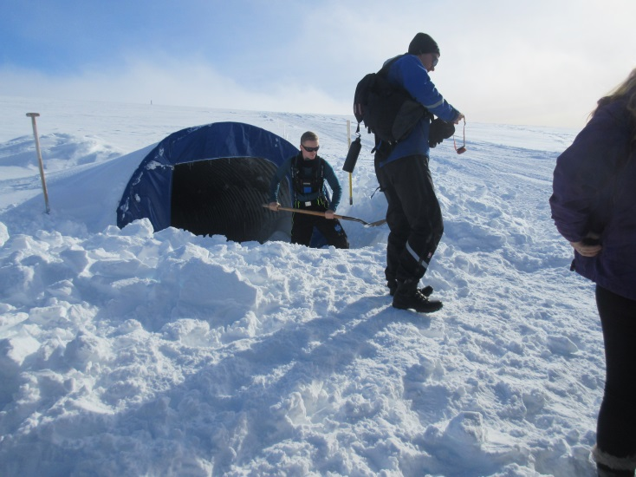
When the truck stopped, we noticed that adjacent to it there was a hole in the ground and a young male was fashioning stairs out of the ice with a shovel. This is where we were going. We arranged ourselves in a single-file line and were led into the glacier’s depths. There were some rubber mats laid out to help with traction for the first few hundred feet or so and we arrived in a room carved out of the ice in which there were a couple of foot lockers and some benches. The foot lockers contained lesser crampons (as compared with the ones that we’d previously used) that were made of rubber and had bits of metal stuck into them. They strapped on in a much simpler fashion, but since it’s difficult to move when one is bundled up, some people (Sue and others) needed assistance with this step. Once everyone was strapped in properly, we continued our journey.
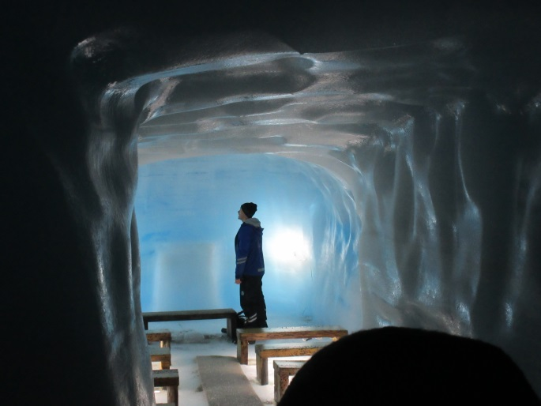
The tunnel into the glacier is in the shape of a heart on a stick. It was meant to be more circular, but there were a few miscalculations along the way as well as some unsettling noises at times, so the route was adapted as needed. Everyone seemed pleased with the eventual shape. At various points along the way were placards discussing glaciers in general and this glacier in particular. There were a few smaller rooms, one of which is a chapel where people occasionally get married. Our guide had us wait outside while he went in and sang us a song (it turns out he is an actor, not a glacier scientist, and this tour guide gig helps pay the bills). Afterward, we all went inside the chapel where we received another lesson, this one regarding the makeup of the “snow” that was all around us, which was made of shards of ice as opposed to softer crystals. We then took photos and continued with the tour. The tour lasted for around an hour or so, and we were pretty deep inside the glacier: around 40 meters under ice at one point. Neither of us was too worried about this, but we didn’t mind getting back outside, either.
Leaving the glacier was the reverse of getting there, with one exception: Sue stopped at the gift shop at the visitor center and purchased a light coat for herself, for which she forgot to collect the VAT paperwork, so Iceland scored some extra tax money for that. Once back in our car at a little before three o’clock in the afternoon, we mapped out our route, using Garmin, to the Icelandair Hótel Reykjavík Marina which, as you recall, is the first place we stayed on arriving in Iceland.
This time we checked into a Junior Suite since we’d be there for a few nights (Nordic Visitor messed up and booked a regular room, but charged us for the Junior Suite, so we had them correct the error a few days prior to our arrival there). The Junior Suite was a nicely sized and appointed room and came with breakfast each morning. Since we were a little tired, again, from the day’s activities, we decided to just have a quick dinner at the restaurant in the hotel called the Slippbarinn. It was OK, but not great, so for the rest of our time in the capital we decided to eat out at other places.
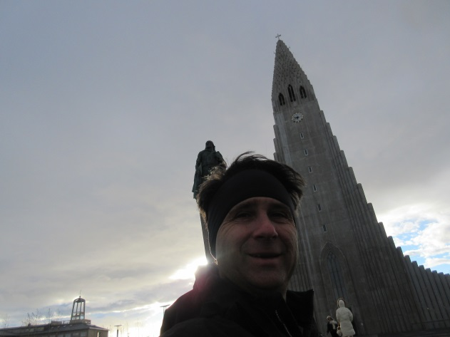
The next morning, Monday, October 1, 2018 we ate the excellent breakfast at the hotel and went back to our room to get ready for our scheduled Guided City Walk at 10:00 AM. The weather was iffy, as it was on many of the Icelandic early autumn days, so we dressed accordingly. Actually, as I’ve previously mentioned, we never left any of our hotels not dressed in many layers with hats and gloves and rain jackets because one never knows how the weather will be. We consulted our city map and headed out on foot to find the meeting place for the tour. It turns out that it was cold and windy and raw with rain threatening, but we were dressed well for it and had no problems. We arrived at the church that was the meeting point about fifteen minutes ahead of the scheduled tour, so we went inside to look around. The church, the Hallgrímskirkja Church, is located next to the Leifur Eiríksson Statue that was donated to Iceland by the good people of the USA on the 1000th anniversary of the establishment, in 930 A.D., of their parliament. The statue predates the Lutheran church, which is relatively modern. The church itself boasts a tower that is one of the highest points in Iceland and one can take a lift up to the top (for a small fee) and view the city. We did this eventually, but not on this day since we had a tour of the city scheduled.
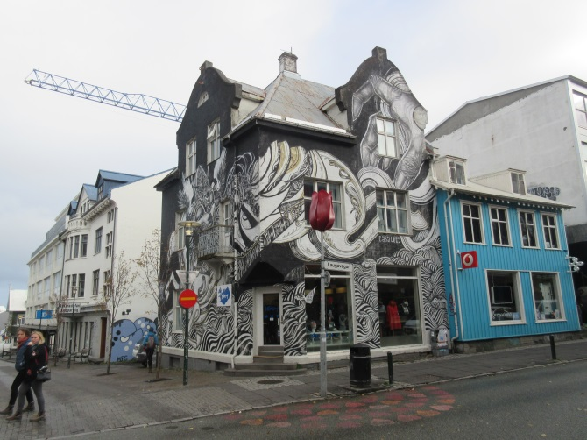
When we went back outside, Sue and I noticed two other couples milling about and they mentioned that they, too, were waiting for the tour. A short time later we all saw our guide approach. She was wearing a bright yellow jacket with the name of the tour company printed on it. She checked us all off of her list and said that was everyone, so we set out on the tour. Our guide took us to show us interesting houses, fences, street art, wall art, the prison, the parliament building, the Harpa Concert Hall and Conference Centre (home of the Iceland Symphony Orchestra and the Icelandic Opera), some interesting monuments and sculptures, and a building dedicated to the history of Iceland (geographic, political, social, flora, fauna and culture). Our tour included lunch, but we needed to be back at our hotel room so that I could sign into Tock at exactly 1:00 PM to make reservations at Eleven Madison Park for our anniversary dinner, so just before the rest of the group headed to their lunch, we excused ourselves, tipped the guide, and went back to the hotel. At the same time that I reserved our anniversary dinner, I made reservations for Dirt Candy on another evening and for the Yotel, where we’d stay. I was successful with all of the reservations.
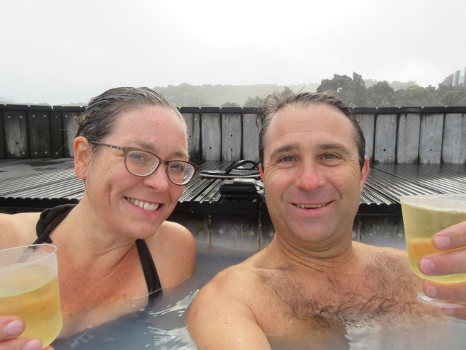
Once we made the reservations for our anniversary trip to NYC, we got packed up to head out to the Blue Lagoon. We had reservations featuring the Comfort Package, which included one drink from the bar, a soak in the lagoon and a mud pack for our faces. The location of the mud pack treatment wasn’t too obvious, so we skipped that, but we took advantage of the rest of it. The Blue Lagoon is very nice: clean, lots of room, not sulfur-stinky. Sure, there were lots of people there, but there is plenty of room for everyone. We stayed for almost an hour and quite enjoyed the experience. Then we headed back to our hotel to get ready for dinner.
We decided to walk into town for dinner and we found a small sushi restaurant called the Sakebarinn. It was located on the second floor of a nondescript building and to get there, we needed to ascend a narrow, dark (unlit) staircase that led to an extremely heavy, unfriendly door. Frankly, I thought that maybe the place was closed, but I wrestled with the door and got it to open and lo and behold, a bright, cheerful space was on the other side. We were the only ones there (it was early) and we ordered our usual feast, similar to what we’d order at the Kaizen in Sturbridge. On the way back to our room we purchased some wine from the Slippbarinn and enjoyed it while watching a program on extreme weather.
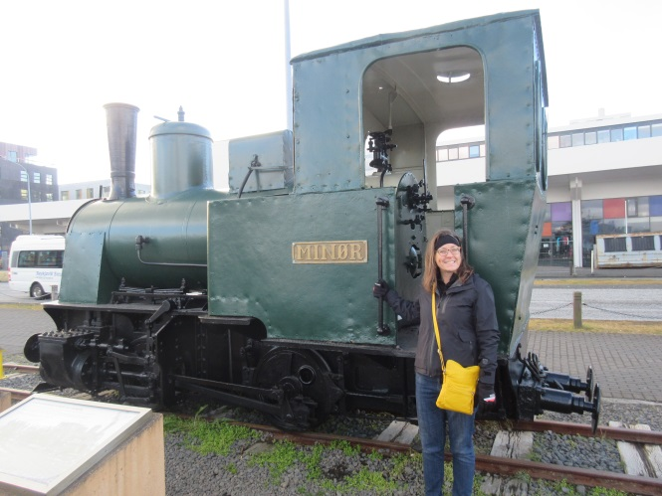
The following day, Tuesday, October 2, 2018, was completely open. We’d noticed a few areas on our drives and walks that we’d be interested to visit. After a leisurely breakfast, we got bundled up and revisited a couple of the areas that we’d briefly explored during the windy, rainy city tour we’d taken the previous day. We started down by the docks, where the entire, three-ship Icelandic Navy was moored. Also in this area is the engine of the one-and-only train to ever be on the island, used to move items and people during the major construction that initially took place in Reykjavík. It is since decommissioned and occupies a place of prominence among other historical statues and plaques in this area. This walk is directly across the street from the Reykjavík Art Museum, which we did not visit.
We next took a walk closer to the center of the city where exists a monument to the two, probably legendary, pieces of driftwood that were the inspiration for first settling the island in the area in which it was eventually most heavily populated. There are two pipes that are warmed nicely by the ever-present steam so that one can warm one’s hands on the coldest of days, which we did, even though it wasn’t. This area of town also sports many themed bars and a number of clothing and jewelry outlets for one’s enjoyment, not to mention eating establishments. We didn’t visit any of the bars, but I can’t say the same for clothing and jewelry stores. Sue decided that she needed some of each, so we stopped at Canada Goose first, followed by window-shopping a few of the jewelry stores, all the while admiring the nice murals painted on many of the buildings of the downtown area.
The window shopping eventually led to a purchase or two, one of which I bankrolled since it is my practice to purchase the occasional piece of jewelry for Sue. There are many pieces of jewelry for sale in Reykjavik composed, at least partly, of volcanic matter, which on the whole is not too surprising.
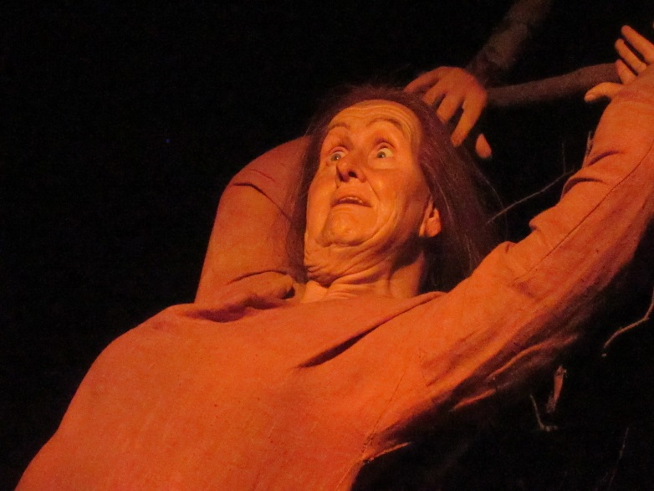
Next, we decided to go to the Viking Museum, which we’d noticed was close by to our hotel. It was a self-paced tour, somewhat, because one is given a set of headphones attached to a device that provides a narrative for the various dioramas that make up the large display. There were a few other people in the place, but since we were all tethered to the set-pace narration, there was no bunching up of groups, as could occur, say, at a golf course. There is a small gift shop and associated room where one can don some clothing, presumably replicas, similar to what the Vikings may have worn. We didn’t try anything on, and didn’t purchase anything from the gift shop.
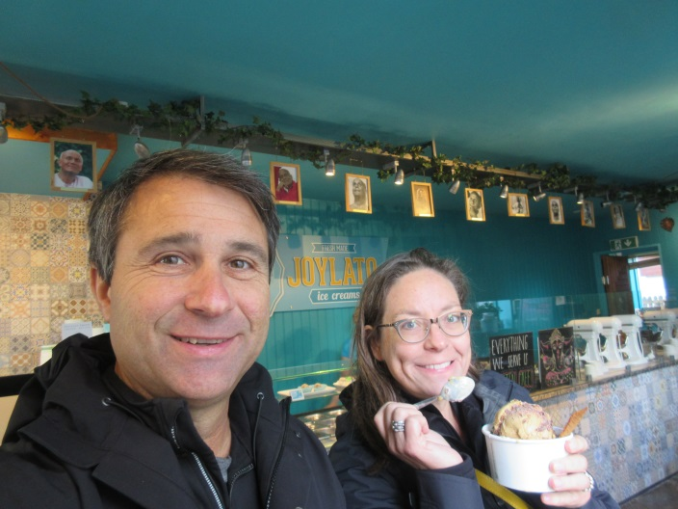
We also stopped briefly by a Northern Lights museum that had some displays and a gift shop. There was no admission charge, or at least I didn’t record one. Since everything balanced when we got home, it’s unlikely that I didn’t record a charge and there was one; there’d certainly be a discrepancy that would require resolution. There were quite a number of great items in the gift shop but we were worried about packing space, so didn’t purchase anything.
Later, we headed back up toward the center of town because we’d seen a place called “Joylato,” which offered vegan ice creams. During our tour the previous day, we decided that we’d have to try the place, for obvious reasons. Sue was skeptical, but I was not. We both found the place to have excellent offerings, and there were books for sale by a person that appears to be promoting peace, possibly a yogi of some sort, but I can’t recall and we didn’t purchase one of his books. While in town, we also went up in the Lutheran church tower to see the views of the city, and purchased some wine for later in the evening.
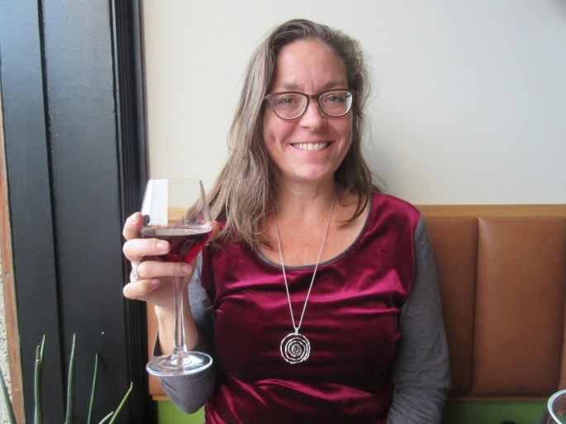
For dinner, Sue found a place she wanted to try called the MatBar. They have a vegetarian tasting menu that Sue thinks was the best meal she’s ever had, and I agree that it’s certainly up there in the top three, if not the top. After all, we have Eleven Madison Park, Vetri and Kajitsu (among others) to consider. We made our reservations, as is our custom, for the earliest possible dinner seating and were the only customers for the first half-hour or so of our fantastic meal. We enjoyed the meal with the wine pairing.
On our last full day in Iceland, Wednesday, October 3, 2018, we decided to just go walk around the city and look at a few souvenir shops, where we purchased a couple of items, fill the rental up with fuel and take it easy, for the most part. For our dinner, I chose a great little establishment near our hotel called Salt. Again, our reservations were for the earliest seating and we were the sole patrons for the first half-hour. This place was another great choice, though it wasn’t vegetarian. We chose some locally sourced seafood dishes and had a really tasty and excellently presented meal before heading back to our hotel to pack and get ready to head back to the USA the following morning.
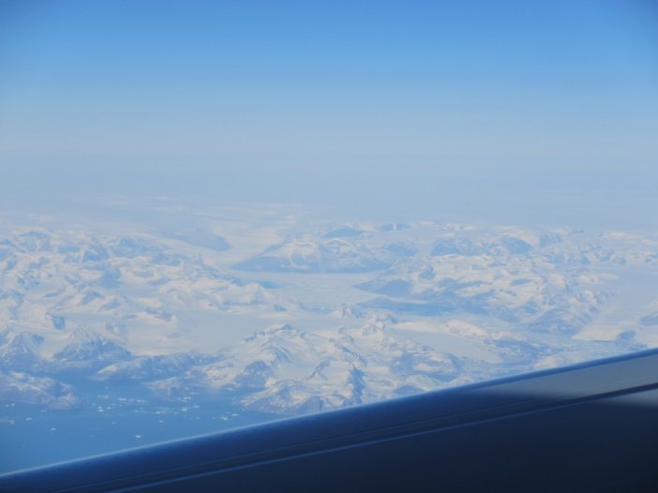
On Thursday, October 4, 2018, we awoke, had a quick breakfast, returned the rental and took the shuttle to the terminal. Prior to going through security, we presented our paperwork to the VAT refund people (we’d each made a few large purchases) and checked in. Once through security, we went to the Duty Free Shop where I purchased some of the Floki Sheep Dung Smoked whisky that I’d tried earlier on our vacation. We then waited for boarding, got on the plane and made our way to the Toronto Airport for our connection back to Hartford.
On the flight to Toronto, we went over Greenland, and since it was during the late morning we enjoyed some spectacular views of the island. Once at the Toronto Airport, we had lunch at the Burger Fed establishment, then boarded our small aircraft and were back in Hartford on-time. The shuttle driver took us directly to our car, which started right away, and we were on our way back to the YBH after an exciting and adventure-packed trip to Iceland.

