BALI & SULAWESI TRIP
THE GREAT INDONESIAN ECLIPSE
SUE AND CHRISTOPHER
FEBRUARY 29, 2016 THROUGH MARCH 17, 2016

Sue and I decided to take a trip to Bali as part of Astronomy magazine’s solar eclipse tour, run by TravelQuest International. The eclipse took place on March 9, 2016 and was visible in its entirety from an island that is conveniently close to Bali called Sulawesi (formerly Celebes). Once we were confirmed as tour members, we made flight arrangements to Denpasar, Bali. We left from our go-to airport, Bradley Field in Windsor Locks CT, otherwise referred to as “Hartford” by some people and notated here as its airport code BDL. The flight was scheduled to take off at 7:05 AM on Monday, February 29, 2016, so we left the YBH at 3:45 in order to get to the airport in a comfortable time. Since we were traveling internationally, we didn’t want to take any chances by cutting our timing too close. The first leg took us to Philadelphia, PA (PHL), where we boarded a Qatar Airways flight scheduled to depart PHL at 10:15 AM and arrive in Doha, Qatar (DOH) on the Persian Gulf at 6:30 AM the following day (there are several time zone crossings, so the flight is not as long as the listed times would suggest, but it’s long). From there, we boarded another Qatar Airways flight leaving DOH at 8:55 AM and landing at Denpasar Bali at 11:10 PM on March 1, 2016.

Prior to leaving there were plenty of preparatory measures that we needed to take, chief among them getting some suggested inoculations: a Hepatitis A series (two shots, six months apart), a typhoid shot and, for the Sulawesi leg, pills for malaria that we’d self-administer, taking first one the day before heading over to Sulawesi, one per day while there, and one per day for ten days following. I also needed to get a flu shot (Sue already had hers). In addition, we carried with us one course apiece of strong antibiotics in case we came down with what is referred to as “Bali Belly,” which is self-explanatory.

We’d both front-loaded a few runs/elliptical machine sessions for the trip in anticipation of there being occasional difficulty with maintaining our regular exercise schedule while on vacation. The first two days, a Monday and Tuesday, immediately ate into my reserves by two days, leaving five. Sue cut into hers, also, but I wasn’t privy to any information regarding her reserve days, so I don’t know how many she had remaining. At any rate, even if we didn’t exercise at all, which was unlikely, we’d just make up whatever deficit we accumulated over a few weeks upon our return to the U.S.

Travel to Bali

The first leg of our journey took us to PHL on an uneventful American Eagle flight that lasted for around fifty minutes. I enjoyed a tomato juice with no ice for my in-flight beverage, having had at BDL our normal breakfast of McDonald’s egg & cheese McMuffin, hash brown and orange juice. I also took a happy pill along with 3 oz. of vodka, pre-packed in a 3-oz. container in my bag of liquid carry-ons.

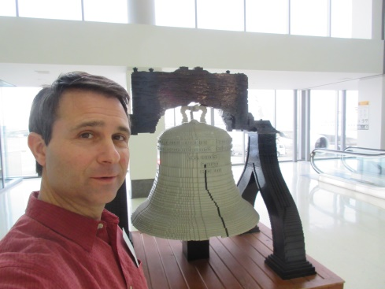
We landed at PHL a few minutes ahead of schedule with plenty of time to make it to our gate. We had to take a shuttle from terminal E to terminal A for our flight on Qatar Air to Doha, Qatar (DOH), and we went to the desk for "passport verification" prior to boarding. Sue charged her device at one of the complimentary charging stations, and I took a couple of photos and waited for boarding to begin.

Our seats for this flight were in the aisle across from each other: Sue in 37H and I in 37F. I'd preordered vegan meals for us, and the crew came around with the first of them in fairly short order. The meals were pasta primavera, heavy on sun-dried tomatoes, a small salad with raspberry vinaigrette, and a bowl of fresh fruit. I asked also for a red wine and a glass with ice. The glass with ice was for water that came with the meal, and then for another 3-oz vodka that I'd taken on board. I also enjoyed another happy pill at this point. After the meal, I opted for a brandy with another glass of water to avoid dehydration.

During all of this food- and drink-related activity, I watched my first movie: a recent James Bond adventure called "Spectre.” Sue watched the Steve Jobs movie, followed by “The Martian,” which I also chose as my second movie after watching our flight path for a while and brushing my teeth. I sometimes watch the flight path screens for hours at a time. After waiting for too long, in my opinion, for another wine, I decided that I should henceforth order two wines with every meal.

Eventually, more wine came, but it was much later and was preceded by an offering of juice, which wasn't what I wanted. In the meantime, I watched the movie “Room” while Sue watched “Black Mass.” After a couple of vegetarian sandwiches, she watched “Room” and I typed my report for a bit.

We strayed, eventually, from the Great Circle route, which would have taken us over less-than-desirable countries such as Syria and Iran. We flew just south of Greenland and Iceland, followed by Cork, Ireland and south of England. We then flew over France and over the Alps to the west of Italy. We made our way over the island of Corsica and flew to the east of Capri. As I wrote this portion of the report, we were at 39,003 feet traveling at 590 MPH over Sorrento and entering the Golfo di Salerno. We’d passed Mount Vesuvius with no problems since it was much lower than we were.

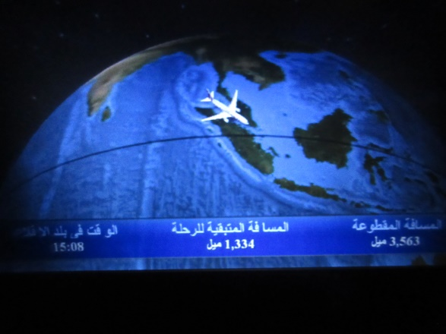
Bali was still at least 16-1/2 hours away, so I decided to watch “Black Mass” to pass a little more time. However, I was unable to finish it because for some reason, the entertainment system reset itself and many in the craft were left with a barely functioning screen with enhanced parental controls activated, I among them. Sue was luckier and was able to finish her movie and watch another. Her full list of movies for this flight was “Steve Jobs,” “The Martian,” “Black Mass,” “Room,” “Everest” and a documentary on the making of a movie about Everest.

Qatar Air, unlike, say Canada Air (which we took to Italy), is not that great regarding timely delivery of wine or spirits. I had a total of three small glasses of wine during the twelve hours+ of the trip over to Doha, and some brandy from the breakfast cart. Luckily I had my happy pills and a spare 3-oz. vodka to hold me over.

Arriving at the Doha airport, we had to exit the aircraft via steps to the tarmac then take a shuttle to the terminal where we had to go through a re-screening process for “transfers,” the definition of which we fit. Despite the hordes of people, the process went surprisingly quickly and we found ourselves with around a one hour wait until boarding at 7:55 for our flight to Denpasar, Bali. We did a bit of browsing in a duty free shop, but didn't find anything to purchase.

The flight from Doha to Denpasar took around 8:44, during which time we ate two meals and had numerous waters and other beverages. I watched “Walk in the Woods” and the Lego movie and the plane's flight path. I also slept a bit. Sue watched “Walk in the Woods,” “The Intern,” “The Walk” and “Me, Earl and the Dying Girl.”

Upon arrival at DPS, we needed to navigate customs, get our entrance visas and look for our ride to our first hotel. I’d arranged for transportation from the airport to our hotel, a trip of only a few miles. We arrived early in Denpasar by around twenty minutes, flew right through customs and met our driver after taking Rp 2,500,000 from an ATM for spending cash. The ride cost us Rp 150,000, and I tried to tip the driver Rp 50,000 (around $3.76) but he adamantly refused, saying that was way too much. The driver also carried our bags up to the room, and again refused the tip that I offered. Door to door, our trip to Bali had taken us around 31 hours.

We were beginning our vacation one day prior to the tour start, so I’d booked a hotel for the first night called the Swiss BelHotel Rainforest. The deluxe suite with breakfast cost $42. There would be no rush later that day to get to the first hotel where our tour would be starting since people would be straggling in all day from various parts of the world.

Apart from the tour activities (an itinerary can be accessed by clicking on the appropriate button at the top of this report on our website), Sue and I had a variety of things that we wished to do while in Bali. We’d each read a few books about the island, including “A House In Bali” by Colin McPhee, the latest tour guide and “The Balinese,” and we’d also perused a couple of maps, and in so doing we came across areas we’d like to visit, performances we’d like to see and activities in which we’d like to participate. Among these were such things as a gamelan concert, puppet theater, shadow theater, temple tours and any rituals that would be appropriate for the time of year and for us to observe. The tour itself included some of this, but we thought it would be nice, since most of our afternoons and evenings were supposed to be free, to see some of these in greater detail. Also, the Balinese are known for their silver and gold work as well as their batik and carving, so we wished to do some shopping, for which we allowed some room in our suitcases. We were, however, prepared to ship larger items back to Dudley if necessary.

We were awake early and enjoyed copious amounts of food at the breakfast buffet. We had taken showers just prior to going to bed since we were awake for around 32 hours at that point and once again after breakfast. Our only goal for the first day in Bali was the 30 minute car ride to the Conrad Bali, check in and have a dinner with our tour group, the first meal included as part of the tour.

At checkout from the Swiss BelHotel Rainforest, we requested a car to take us over to the Conrad Bali. We negotiated a price of Rp 250,000 for the ride, or around $18.35, which seemed reasonable to us. The drive took us through some pretty depressed and poor neighborhoods of the island before going through some guarded gates to the resort side of southeastern Bali. Our driver remarked that this was much nicer of an area than that from which we'd just traveled, and that the Conrad Bali seems like quite a nice hotel. Before being allowed on the property, his van was checked by a dog for drugs and explosives while another guard used a mirror to look at the undercarriage. Thankfully, the vehicle passed these tests and we were driven to the front entrance. Before leaving, the driver gave us his card, shook our hands, bowed and wished us well.

Conrad Bali and TravelQuest Tour

Meanwhile, two hotel employees took our larger bags inside and gave us a baggage check ticket. We went to the front desk, but since we were about 3-1/2 hours early for check-in, our room wasn't ready. Regardless, we were handed a welcome drink and shown to the TravelQuest check-in area where we met two coordinators and received our official welcome packages. While we enjoyed some nice welcome drinks, no fewer than four people checked on the status of our room. Soon, we were escorted up to the fourth (top) floor by a baggage handler and brought into our very nicely appointed room overlooking the pools with the Badung Strait in the background. Our room had a nice balcony from where, as it turns out, I wrote this bit of the report.

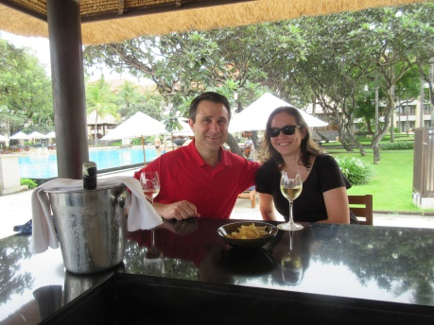
We decided that, since dinner wasn't until 7:00 PM, we'd walk the grounds a bit. We wended our way around the huge, meandering pool down to the beach, where we stuck our feet into the warm, welcoming waters. After rinsing our feet off and re-donning our footwear, we made our way to the side of the property where we found a little market area from which I purchased a batik shirt and Sue a sarong. We decided not to bargain and paid the full asking price of Rp 230,000 for both items. We then stopped at a beachfront, thatch-covered bar for a glass of wine, then up to the room where, even though we said we wouldn't, we napped almost until dinner.

Dinner was quite nice and relatively spicy. Buffet-style, we had no problem finding a great many offerings that fit with our diet. After dinner, we went to the hotel bar and enjoyed a wine while speaking with a local Balinese waitress, at her request, about the eclipse. Tari, the waitress, was very interested the eclipse mechanics, which I was happy to explain, but my task was complicated by Tari’s considerable knowledge gaps regarding the rudiments of the subject. She asked at various times whether the Earth moved, if stars and planets were the same, what the Moon is, whether stars are on one side of the Sun and planets on the other, what the Sun is, whether the Sun moves and, most importantly, what happens during an eclipse. She also thought that it would be dark for the day on Bali and that I was from NASA and had been to outer space, even though she wasn’t quite sure what outer space was. At one point, she told me that during a class that she once attended she learned the name of nine galaxies: Jupiter, Mars, Saturn…. I finally had some success by using various bar-top items such as the snack bowl, wine glass and coaster as visual aids to represent what happens during an eclipse, and Tari seemed to appreciate it.

The next morning, Sue and I arose early (around 6:00) to have some coffee and get to the gym for our first exercise session of our trip. Since a housekeeping oversight left only decaffeinated coffee available in the room, we opted to brew some English Breakfast Tea. We then made our way to the fitness center, where there was only one other gentleman exercising when we arrived. By the time that we left, several more individuals had joined us.

After showering, we went to breakfast, which was very nice. It was buffet style like the dinner, and included a mix of Balinese, Asian and western options. Luckily, there was also plenty of coffee. Unaccustomed as we were to this style of dining on a regular basis, we were getting into the poor habit of having dessert with each meal, breakfast, lunch and dinner. After a couple of days of this, we adjusted our buffet dining to no desserts. After lunch, we’d be going with the group on our first temple tour.

Temple Tours – First Day with TQ Group

On the schedule for the afternoon were a couple of temple visits followed by a sumptuous dinner at the Pan Pacific Hotel. Buses were assigned based on our TQ badge numbers, but that system quickly deteriorated into people just choosing a bus at random. There were four buses and we ended up on the last one. Instead of being labeled Bus 1, Bus 2, etc., buses were given bizarre designations like “1A Bus 2” and people needed to remember the choice that they made on that first day, leading to a great deal of confusion throughout the remainder of the ten-day tour.

The bus rides throughout the tour took us over very narrow and extremely busy roadways. The roads were barely large enough for two small cars to pass by each other, but all sizes of vehicle, from bicycles to motor scooters to large trucks traversed the roads, passing each other on both sides, occasionally tooting horns (in a friendly manner), turning at odd times; I was thankful that we heeded the advice of the travel guidebook to let the natives do the driving for us while visiting the island since Balinese drivers seem to anticipate each other’s moves quite well.

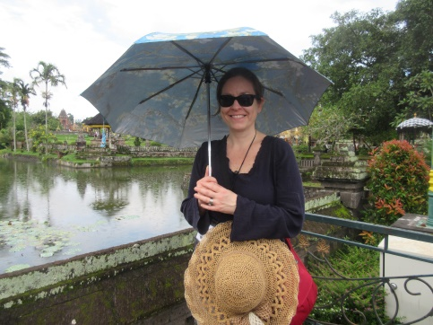
We arrived at the first temple, Pura Taman Ayun, and were given about an hour to walk around, observe the ceremony that was taking place on that day and take photos. We viewed the ceremony and saw gamelan instruments set up on one of the platforms. We were lucky enough to see several performances featuring Balinese gamelan music, which is almost entirely unlike any western musical style, but very enjoyable once one gets accustomed to it and especially when it is accompanied by a dance performance.

Once everyone was back aboard the buses, we made our way to the second temple, Pura Tanah Lot, or “Temple of Land in the Middle of the Sea,” so-called because during periods of high tide, the temple looks as if it's afloat on the ocean. There were crowds of tourists as well as natives selling flying toys, postcards, fake flowers and even the opportunity to have one's photo taken with a seven foot long boa constrictor. Again, we were given an hour to walk around. This temple was spread over a much larger area than that of the first temple. We were drinking a good amount of water and needed to use the facilities, but the only available ones charged for their use, and, cheaply, we didn't feel like paying, so we both waited until we arrived at the restaurant at the Pan Pacific Hotel, where we were to have dinner and watch the sunset within view of the second temple.

The dinner area at the Pan Pacific Hotel looked as if it were set up for a wedding reception. On the walk over to the area, we passed two priests praying over offerings in hopes that the gods hold off the rain for the duration of our dinner. It seemed to have worked just fine, although the sunset wasn't without its share of clouds. Dinner was nice with complimentary soft drinks, beer and wine, and since no one was driving, everyone took full advantage of the latter two items.

After dinner, which was buffet style, of course, we made our way back to the Conrad Bali, arriving at around 8:50 PM. Sue and I went right to bed since we wanted to get up early to exercise before the next day's activities.

Temple Tour, Rice Field – Day Two with TQ

We awoke just before 4:00 AM, had a couple of coffees apiece, and were at the Fitness Center by 5:00 AM. After showering, we went down to breakfast for 7:00 AM, ate, and prepared to meet up in the lobby at 8:00 AM to head to another temple and then to a rice field where we’d be having lunch.

The temple, Pura Ulun Danu Bratan, was by far much lovelier than either of the examples that we visited the day before. The grounds were well-manicured, the statuary was interesting and nicely accented with flora and it was situated on a lake, Lake Bratan. There were several water activities available such as pedal boats and other boat rides and there was a temple ceremony with procession occurring in and around the temple area and paths. The participants in the ceremony were adorned beautifully and carried all manner of offerings, statues and other items on poles. We did need, since the ride took well over two hours, to utilize the facilities (signage referred to them as "TOILET"). We paid a price for the privilege, though: 2,000 Rupiah each for each use, totaling Rp 8,000. At the going exchange rate, that was around sixty cents USD, or $0.15/use.

The ride up to the temple was interesting in that we passed through many Balinese neighborhoods giving us a glimpse into the lives of everyday Balinese individuals. Since it was a "main road," I suppose it wasn't exactly representative of all village life, but we witnessed numerous things of which I'd read in a few books on Bali prior to our trip: community temples, individual temples, beautiful gates, protective statuary, offerings, small shops and markets, rituals, etc.

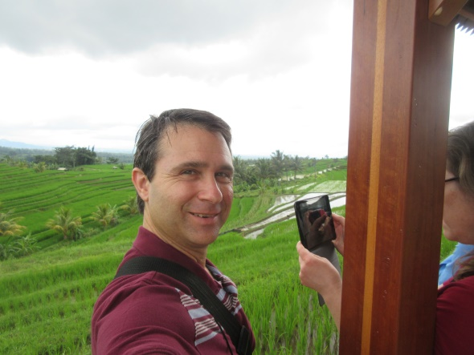
After the temple, we boarded the bus for a 1:10 ride over to the "most beautiful" rice paddy on Bali, located in Jatiluwih. That is a description with which I’d have to agree. We were allowed a little time to walk along the road and take some photos, following which we ate lunch at a restaurant overlooking the paddies, entertained by two gamelan musicians. As we walked to our table we were followed by two waitresses, each carrying a coconut containing, appropriately, coconut water for us to enjoy during lunch. That was my first experience with coconut water, which is sweet and refreshing. I also had a first taste of a fruit, mangotine, which is subtle and delicious and nothing at all like a mango. On this trip we sampled numerous fruits with which I was previously unfamiliar, all unique and all tasty; everything is always in-season and plentiful in the tropics. After lunch we noticed that there was a rice paddy worker with an ox that was plowing a nearby paddy; we took a few photos of this activity.

After we finished with our lunch we headed back to the side of the road to take some photos of the ox, then Sue decided to go back upstairs to take a movie of the gamelan players. After such a nice excursion as this, the bus trip back to the hotel seemed particularly hellish and long. When the guides told us that we'd be back at the hotel in around two hours, they really meant three. Since the roads were small, the buses had to stop and/or slow frequently to allow other cars to pass or to pass scooters, which was irritating, and some of the other eclipse travelers would sometimes try our patience.

During dinner that evening, back at the Conrad Bali, we were able to watch a show of Balinese dance called the Kecak (or Ketjak), also known as the Ramayana Monkey Chant. It was an amazing performance. I'd previously read that the performers not only learn all of the dance moves precisely, but that their facial expressions, hand and finger positions, and even eye movements are all precisely choreographed. The dance itself, according to Wikipedia, tells a story of a battle from the Ramayana in which the monkey-like Vanara helped Prince Rama fight the evil King Ravana, and was developed in the 1930s.

Ogoh Ogoh, Batik, Jewelry En Route to Ubud, Bali

The next morning we found our bus, 1A Bus 2, and left for the Alila Resort in Ubud, Bali. Several stops were planned. The first was to witness various Ogoh Ogoh statues being prepared for the Nyepi (Balinese New Year) Celebration that took place this year on 3/8/2016. Nyepi itself was on 3/9/2016, the date of the "Dark Moon," which, of course, is the New Moon and coincided with the date we were off-island, visiting Sulawesi for the eclipse. The fact that we were off-island for Nyepi was fortunate as no activity whatsoever is allowed on Bali during Nyepi from 6:00 AM through 6:00 AM the following morning. No cooking, fires, driving of vehicles, use of electronic devices or even people leaving houses is allowed. We’d have needed to remain on the hotel grounds for the duration.

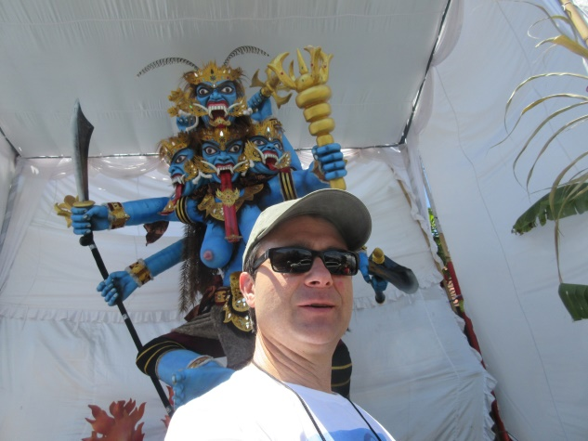
Our travel took us through a very busy, bustling village. The streets, to westerners like us, seem chaotic, but the locals navigate them with calm and skill. Every type of vehicle from large trucks and buses to children on small, two-wheel bicycles traverses the narrow passages with no street lights while maintaining a beautiful flow. Our buses pulled over onto the side of a road and let us out. We were guided past two Ogoh Ogoh statues being prepared for the festival, of which we took a few photos, and into a large, open-air hall where other offerings and statues were being prepared by locals for the upcoming festival. It was interesting, but hot and lasted for around fifteen minutes too long.

We next made our way to a small shop where batik artists and clothiers worked on looms and with small brushes to weave their own cloth, draw patterns on it, paint the patterns in then cover the paint with beeswax. We were able to watch the artisans at work, and then peruse the small shop for clothing, tablecloths and artwork. Sue and I purchased a few items from this particular shop, as did many others from our group.

Our next stop, prior to arriving at our hotel, was a jewelry-making shop. The Balinese are known for their jewelry, batik and wood carvings. We could observe the artists working on our way into the shop where we were told to "make a collection" with one of the employees, and at the end, to compare the “best of the best” to decide what our purchase would be. This process consisted of us being followed around by an employee with a 1'-square black tray on which was placed every item in which we showed interest. When we were finished browsing, Sue made her choice and we purchased the items.

The hotel wasn't far from the jewelry shop, and we arrived, were given our welcome drinks and keys, and set out for our rooms. We didn't need to "check in" in the traditional sense since the tour coordinators took care of this in advance. Our luggage, also, was already in our rooms, so we didn't need to worry about that, either. We made our way up to our room at the Alila Resort, #227, which was a several-minute walk from the "lobby" area up many flights of stairs. Well, the room was a beauty, photos of which are available on the accompanying slide show, with a furnished deck and subtle lighting. It overlooked the lush Ubud countryside that is rife with roosters and monkeys. There was no television in the room, and the bathroom had a shower with a glass wall overlooking the countryside to the rear of our room. There was a block wall-like structure that made the shower stall not easily visible from any pathways associated with the property, allaying any privacy concerns.

We settled in and made our way down to the lounge to await dinner, scheduled for 7:00 PM. The lounge is adjacent to the pool, which also overlooks the beautiful valley. The pool is in the style of an infinity pool, but there is no ocean visible from Ubud. An extinct volcano range could be seen from the room where we stayed.

Dinner was incredible, and served individually as opposed to buffet style. Sue and I had a fresh papaya-topped salad to start (others had chicken on their salads...we came out ahead), followed by a pan-seared sea bass with pickled fennel on the side and some sort of sauce. Dessert was similarly excellent. We enjoyed a bottle of Marlborough New Zealand Sauvignon Blanc with our dinner, and we met (again) Slade and Simone from San Francisco and Peter and Barbara from British Columbia. We mentioned to the former couple that we were seriously considering not going with the group on the planned tour the next day and they replied that they were planning on taking a private "Trek Tour" through a village, private house, rice paddies and river, ending with a picnic lunch and coffee tasting at a coffee plantation. They invited us and we readily agreed! (Peter and Barbara declined, and, it turns out, that was the correct decision for the two of them.) Our plan was to meet up for breakfast the next morning and then to meet with the guide at around 8:00 AM to head out.

Off-Tour Trek with Simone and Slade

Sue and I arose early the next day, enjoying some in-room espresso before heading down to breakfast at 7:00. We arrived, but there was no sign of Slade or Simone. We ate our breakfast at a leisurely pace, still with no sign of the two of them, and decided that they must have left earlier than expected for whatever reason, so we went to the front desk to inquire about a tour of our own. Unfortunately, all of the tours were booked, so Sue and I decided to go into Ubud to do some shopping and have lunch. We went back to our room where I got to work on this trip report for a while. At around 8:30 AM, our phone rang. It was Slade from the lobby wondering if we were still interested in going on the trek with them. It turns out that they got a later start than expected (they enjoy sleeping in) and still wanted us to go. We headed directly down to the lobby.

They had chosen a Trek with an add-on of a picnic lunch for Rp 600,000 per person. We paid Slade directly since he'd already put all of our fees on his credit card. He and Simone also signed waivers, but that technicality was overlooked by the tour coordinators for Sue and me. The advertisement for this Payangan Countryside Trek said “Enjoy approximately three hours of wonder as you walk through the lush local countryside featuring some of the most impressive rice terraces, rivers and waterfalls. …enjoy a refreshing drink of coconut milk direct from its natural source. The experience ends with a beautifully laid out sumptuous picnic in our private bale overlooking rice fields.” My wife almost wore her new batik dress for this trek based on that description, but luckily decided in favor of more traditional hiking attire at the last minute.
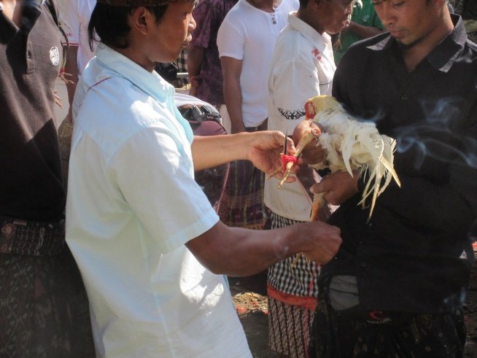
Our first stop was a small village where a festival was well underway by the time we arrived. There were many cars as well as countless scooters and motorbikes parked along the road and in the woods. The crowds were thick with local Balinese, some with offerings, some with goods for sale, some taking part in processions or rituals and others carrying roosters for impromptu cock fights. We witnessed a couple of temple ceremonies and a few cock fights (something I never expected to see!) before heading back out into the village to tour a house.

The climb up to the house, well outside of the center of the village, took us through a very woodsy and sparsely populated area, then up a slippery and steep rock path that was slightly worrisome to at least one of our group, but little did we know that this was to be one of the milder portions of our trek for that day. At the top of the stone path we went through a narrow alleyway, then came upon the house that we were to visit, prearranged by our guide, Suara. He explained about the outer gate leading into the yard where one first encounters a wall (to trick evil spirits). Around the wall is the living area which is arranged as a human body, with the head, body and lastly legs/feet areas. The head is where the house’s temple is located (every house in Bali has one). In the temple occur all manner of ceremonies including, most importantly, those associated with birth, marriage and death. We were told that after the marriage, the newlyweds walk to the adjacent building, just a few steps away, for their honeymoon night. When there is a death in the family, the body is laid out and prepared for the cremation ceremony in that same temple.

Adjacent to the "head" is the "body" consisting of the traditional kitchen containing a pantry area and a wood-fired stove. It is very small, even compared with the kitchen at the YBH, maybe twenty-five square feet. Outside of that room is a rice drying and storage loft under which the women of the household prepare the various offerings for either daily or special ceremonies. The freshly harvested rice from the family's paddy is stored in the loft for drying before it is prepared for offerings or meals. The family matriarch was busily preparing offerings during our visit, including some of the bases that can be reused in case of "emergencies," according to our guide. I asked what constituted an offering emergency, to which he replied an unexpected death in the family or in a neighbor's family.

Next to the offering preparation area is a more contemporary cooking area, often using a fossil fuel such as propane. This house had a small table near the propane stove on which some food preparation was underway during our visit. There was also a pot of food being heated on the stove. The traditional kitchen was not in use at that time.

The "legs/feet" part of the house consists of animal dwellings and the waste collection area. This particular family had two cows and four pigs as well as a number of chickens. The cows are raised to sell at market, as are, I believe, the pigs. The chickens weren't mentioned as far as I can recall, but judging from the festival that we'd just seen, some may be roosters for cock fighting. Others may be egg-laying hens and others could be raised to eat or sell. Most families own a portion of a rice paddy and work some other job as well. Neighbors and communities cooperate with each other to harvest the paddies, and even when locals are just passing through the fields they often stop for a while to lend a hand with whatever task they see being performed by their neighbors. Our guide mentioned that he often does so.

Each house on Bali is built under the guidance of a priest, with proper ceremonies and offerings being performed on the proper days (building of certain parts of the house can only occur on certain days based on the various calendars in use under the Balinese religion, which is a unique mixture of Hinduism, Buddhism and other local influences). The “head” section of the house is always oriented toward Mt. Agung, the spiritual center of the island, and the “feet” section is always oriented toward the sea. Mt. Agung is "north" no matter where on the island one is located and the sea is always "south."

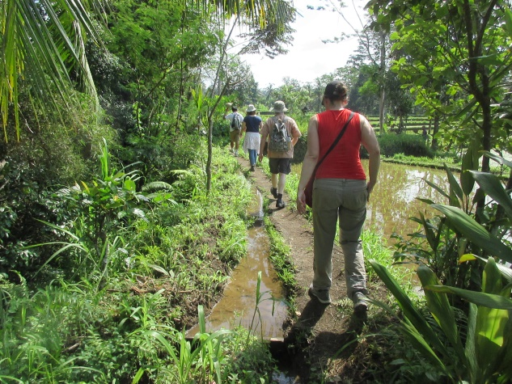
We thanked the owner of the house and moved on to the rice paddies. I was under the impression that we'd be walking adjacent to the fields, but that impression was a mistaken one. The paths adjacent to the paddies were very narrow and consisted of mud and grass, often with parts of them breaking away into the water, along with our feet. We later found out that king cobras are frequent denizens of paddies and that the workers in the Balinese paddies enjoy the highest incidence of venomous snake bites of any group on the planet. I'm glad we didn't know that ahead of time. We witnessed a few workers tending the paddies and a few women walking through with offerings on their heads, most likely on their way to a ceremony. Suara persuaded one local lady that was passing through the fields to stop and take photos with us. He then showed us an offering stand at the start of a paddy and pointed to the start of the next paddy where there was another stand. He explained that each marked the beginning and end of one family's portion of the field of paddies. Most stands had fresh offerings in them, some with incense burning.

Out of the paddies after about a 30-45 minute walk through them, we came upon small village where some people attempted to coax us into their shops to purchase clothing or convenience store items. One shopkeeper posed with her son so that we could take a photo. We didn't purchase anything in these shops. Taking a corner into an even smaller village that was somewhat artsy, we noticed many house entrances with the Hindu god Ganesh represented on the inner wall. There was also one gentleman that was carrying three very long, thick pieces of bamboo on his head toward the village center, probably to prepare statuary (small Ogoh Ogoh, maybe) for the upcoming Nyepi celebrations, but that's just a guess as we didn't ask him.

Now our guide said that we'd be heading down to the river via a path that he described as "difficult" in spots but worth it because it's quite beautiful down there. We four were relatively young and/or in good shape, so none of us were too worried, and besides, we'd survived the trek through the paddies, so how bad could this be?

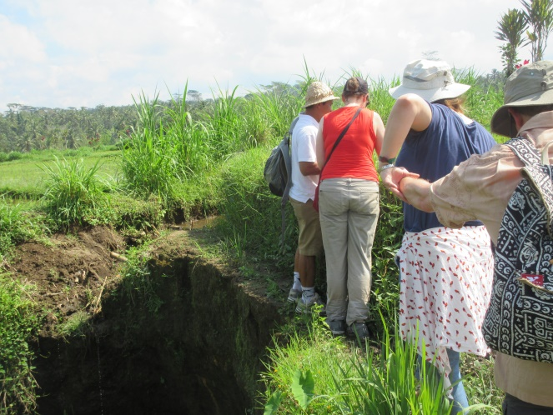
After leaving the paddy area and encountering a temple where a ceremony had just finished up, we came across a steep and winding incline down some slick rocks, followed by some stone steps that were clearly not built to code. It then appeared as if the path disappeared, but our guide assured us that "this is the path" but to be careful and "hold onto the grass" on the way down so as not to fall into the yawning crevasses on either side. I decided these challenges were better negotiated doing "the crab," and others in our small group just slid down on their rear ends. Next, we came to a seven-foot long, one foot wide dirt pass on a sheer cliff with a drop of around 100' on one side and a "wall" of dirt around four feet high on the other. There were no safety railings or handholds of any kind here, and we were told to face the dirt and shuffle along the other dirt, again holding onto the grass.

A short time later, after a few more worrisome passes down steep inclines, we could see we were getting closer to the river. We were in a beautiful valley area around which were some buildings nestled in the foliage, one of which was a house and the other two having to do with the coffee plantation that was our ultimate goal. Our guide pointed the latter out and said that was indeed our destination, but it was on the other side of the river and very, very far up the cliff. Some in our group were beginning to flag a bit, and some groans were heard at this point. But soldier on we did, because it was either that or make our way back along the hazard-filled route we’d already covered.

Maybe fifty or so feet farther down we went, with a dangerous drop on our left and not much to provide purchase on either the path or to our right when we came to some running water that was coming out of a thin, maybe 1-1/2'-wide cement U-shaped channel that crossed around 300’ over the chasm, at the bottom of which ran the aforementioned river. Our guide suggested that we could rinse our hands off there if we'd like because the water is very clean, and that we’d be crossing the river by walking along this cement trough. Looking at the thin ribbon of cement made not for human crossing, but to channel water, it began to sink in that this was a terrible predicament, but our guide, ever-optimistic and cheerful, smiled and said "no problem, you can hold onto me and we’ll go across."

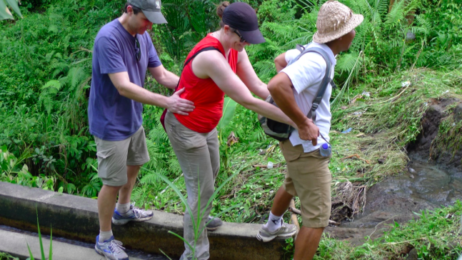
Of course, this was a problem, but we didn't have much choice since backtracking out seemed like an even worse option. Slade and Simone decided to go first or maybe they just did so because they happened to be nearer to Suara, our guide. He was in front, then Simone, holding onto his waist, followed by Slade holding onto hers. Suara showed us how to place our feet on the corner of the channel "walls" and counted off steps: “one, two, no problem.” I took some photos of Simone and Slade while they went over and thought to myself, "Will these be the last photos of these people alive?" After a few minutes they were across, visibly shaken, and Suara bounded back over for us. I didn't even want to climb up on this channel, never mind go across it, but Sue climbed up and grabbed the guide and I somehow followed putting my hands on her waist. I was crying the whole way over, just like a little girl, and Sue was laughing at the absurdity of our situation. The guide was saying "no problem" and counting off steps. I stared down at the water flowing through the channel and concentrated on my steps, knowing that if I looked over the side of the channel at the river below, I'd surely lose my balance and fall over taking both Sue and Suara with me. Somehow, after a seemingly interminable time, we were on the other side. I decided then and there that if our trek was to take us back over this absurd structure, I'd just build a house on the other side of the river and stay there forever. Luckily, all that remained was for us to climb up this giant hillside to the coffee plantation.

Once we all recovered our legs, Suara, pointed to the ridiculous, rocky, slick and steeply inclined path that we'd be following up the several hundred meters to the plantation. We were halted to rest on occasion and to wait for everyone to catch up, but eventually we were nearing our goal. Other non-Trek individuals were now seen, having come in the front way via an entrance gate at a parking area. There was a pool that could have been a natural formation as well as toilets and an area for a picnic lunch. As we passed the latter, a waiter, recognizing Suara, ran after us and ushered us over to the picnic area that he'd prepared for us with a scrumptious-looking repast. The area itself was set up like a typical thatch-roofed structure that we’d seen all across Bali with only a table-like setup in the rear (no seating). On the table was our lunch, consisting of bottled water, watermelon juice, salad with dressing, fresh fruits, a veggie sandwich with mayo and ketchup condiments, a bowl of mini-meatballs (which we didn't eat) and a wedge of rich chocolate cake. We offered our meatballs to our companions and they offered their cake to us. I accepted the offer of cake, but Sue didn't, and neither of our companions had any of our meatballs.

The whole picnic lunch area overlooked the valley through which we'd just trekked, an impressive sight. We all took a look at the pool while there and generally lolled about for a while discussing the day's somewhat nontraditional adventures thus far. After we all finished up, we gathered our things for the last push up a couple of more flights of stairs to the coffee plantation for our tea and coffee tasting.

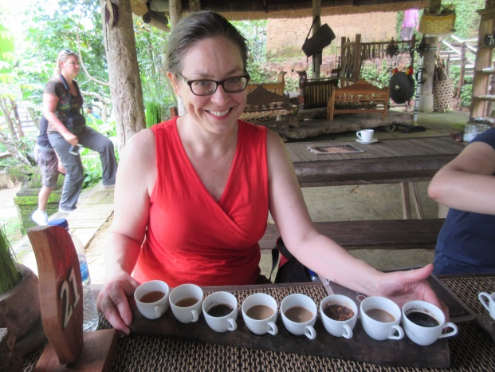
A waitress seemed to know who we were and led us to a little cafe where we'd enjoy our tasting. It comprised ten or so different teas and coffees, all identified on a placard. Sue and I shared one set and Slade and Simone another. Slade also decided to add on a Luwak coffee, made from beans eaten by and recovered from the excrement of a luwak, a Tasmanian devil-like animal that purportedly carefully chooses which beans to ingest. We were able to see one of these animals, but were warned not to go too close as it is aggressive in nature. We also were given a tour explaining the processing of the luwak beans, the preparation of the finished coffee and how spices are gathered and prepared for cooking.

Painting School Stop

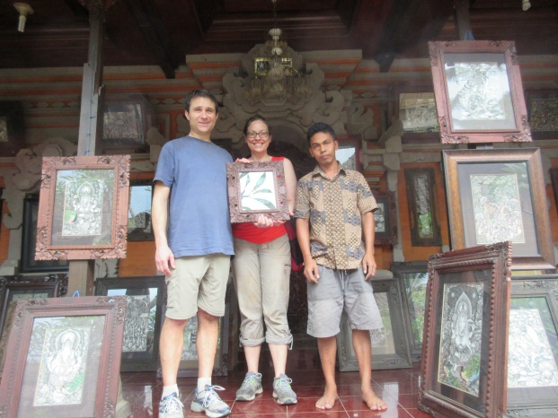
Thanking our plantation guides, we then headed to the van for our trip back to the hotel. On the way we slowed by another rice terrace for photos out of the van windows, but as we were all quite exhausted we decided to not stop. However, when asked whether we'd like to make a stop at an art school where there was a master teacher and students producing traditional Balinese artwork we decided in favor. The master artist would explain the techniques used to produce the paintings and the story behind any of the scenes depicted. It turns out that students, although it was Sunday afternoon, were present working on some of the artwork. The school is set up like a traditional Balinese house with several of the “head” areas given over to displaying finished artwork. We chose to purchase a smaller painting with frame for around $140, and our companions chose two larger works without frame. We got ready to pay, but we were told that the painting we chose was by the artist's teacher which seemed to excite him greatly. He called over someone who may have been his wife to take a photo of Sue and me posing with him and the painting. Our companions chose works by the artist, and were asked to do the same. A percentage of the sales went toward operating the school and a percentage to the artist. Had we purchased art produced by the students, a portion would have been set aside for their continuing education.

We left after around 45 minutes and headed back to the hotel. Sue and I cleaned ourselves up and took a walk down to the pool. A quick detour along the way led us to the hotel's boutique shop. There was some nice artwork for sale there, including carvings, sculpture, masks and paintings, as well as clothing, jewelry and other items for sale. Sue was taken with a pair of silver earrings, but wanted to think it over before buying. We went for a swim enjoyed a glass of wine, after which we headed back to the room to get changed for dinner. On the way back down to dinner we stopped again at the boutique, as Sue had decided to purchase the earrings after all. She put them on immediately to wear to dinner. After another satisfying and culinary adventurous dinner, we went to bed.

Ubud Center

We arose before sunrise, enjoying the amazing espresso provided in the room, then headed down to breakfast for 7:00 AM. We'd determined that we again would not go with the group on the scheduled temple tour, opting instead for a trip into Ubud center to do some shopping at the Market and to see the Ubud Palace. I was sitting out on the back deck writing an update to this report when there was a minor incident with a group of monkeys. They swarmed over the roof and onto the deck, surrounding me. I calmly, without any sudden movements, rose and exited the deck, going inside the room to wait with Sue for the monkeys to move along. Through the shower stall glass, I directed a facial expression at the lead monkey in response to one that he’d just made to me, mistaking his gesture for a friendly greeting. This elicited in him a great deal of aggressive agitation, and caused his cadre of simian cohorts to linger, but things gradually calmed down and we were able to leave our room safely and head to the lobby area where we met up for the van ride into town.

We left the hotel at 10:30 AM. The ride took around fifteen minutes. After being dropped off, we set out on foot to explore Ubud. Our first task was to find an ATM. The provided hand-drawn map showed only one ATM, a short walk from the parking lot if one followed the road east, away from the market. After twenty minutes of walking we came upon the ATM, withdrew our money and went back toward the town. We passed, every few feet, a gentleman offering a taxi which we politely declined. We stopped at a couple of shops but were interested in shopping in the market, so we didn't purchase anything. Maddeningly, once back at the parking lot and looking west toward the market, we spotted several ATMs lining the street!

One of the other tour participants met up with us at this point and we grabbed some water while searching for the Ubud Palace, which we eventually found after she asked directions from a series of people. The palace was nice enough, but we were hot and cranky and wanted to get to the Market. Well, Sue and I decided that the Market is not for us. We hate the high pressure sales and disliked everyone vying for our attention. We eventually purchased a mask for which the woman asked Rp 170,000 and, after some bargaining, took Rp 130,000. She seemed satisfied and I think we were ripped off, but in reality, even though the mask, upon further examination in better lighting, was clearly not of high quality, Rp 130,000 was around $10.00, so it was fine.

Sue had wanted to purchase a bag and we wanted souvenirs for some people back in the USA, but we had to get out of there, which we did post-haste. Walking down the street I started looking for a place to grab some lunch and asked Sue the time. "12:51" was her reply. I asked if she'd like to head back to Alila for lunch and to lounge around, to which she replied in the affirmative, so we high-tailed it back to the parking area since the shuttle was scheduled to arrive for a 1:00 departure. Our tour companion was just getting there as we rounded the corner, having had enough of the place herself by this time, and we all went back to the Alila together. The next shuttle wasn’t scheduled to depart Ubud until 4:00 PM.

Back at the hotel, we changed into our swimwear and went down to the poolside restaurant for lunch. We each had a tuna garden salad with beets, and Sue enjoyed a tuna ciabatta while I decided on a ciabatta caprese. Both of the latter came with fries, and for beverage, Sue had a green iced tea with mint leaves, lemon and lime and I chose a tangerine/carrot/ginger drink from the "healthy drink" menu. After lunch we decided to have some wine poolside and to do some reading. A little while into reading and relaxing and after taking a refreshing swim, the monkeys started appearing.

The first one jumped down from a tree and started walking across the pool apron toward us. The pool attendant and a waiter shooed him away and he went up behind us, eating a bit of the offering in the small offering tower next to us by the wall. Then around six or seven other monkeys started entering the pool area, egged on by some guests and shooed away by the workers alternately. Several made their way past us, not making Sue very happy...not one bit. After a short while she decided she'd had enough and I asked our waiter, Komang, who'd taken care of us many times during our stay, to deliver our wine up to our room, which he gladly did, even though it is a fairly long walk. We'd mentioned that we'd carry it ourselves, but they don't allow that sort of thing around the Alila (guests laboring).

Dinner was again excellent and served, not buffet-style. We spoke with a few members of our group about their adventures on the Lake Batur trip (which didn't return to the hotel until after 7:00!), and about our experience in Ubud. Even though we didn't enjoy ourselves very much in Ubud center, I feel that we still came out ahead in that we had a nice relaxing morning and afternoon, interrupted by only a few hours of nonsense, whereas the other group was gone for nearly twelve hours.

Trip to Palu, Sulawesi

The next morning we had breakfast early enough, although it was supposed to begin at 6:00, but wasn't ready until around 6:30. We had our two big suitcases ready for their trip back to the Conrad Bali, where we'd be on the 10th, after the eclipse, and one small gym bag and two carry-ons ready for our trip to Palu, Sulawesi where we’d view the eclipse. We departed the Alila nearly on time and made the one hour and fifteen minute drive to the airport. Our plane was chartered, a 737-800NG that has a 3-3 seating plan. Sue and I were assigned seats 31A and 31B, but since there was no one else in our row (C-F), we decided to spread out a bit for the 1:55 flight up to Sulawesi, somewhere I never thought that I'd visit. So Sue moved over to 31C and a couple of people moved across the aisle from a more crowded section of the plane before takeoff.

After reaching cruising altitude of 39,000', lunch service began. There were two vegetarian meals prepared for Sue and me, consisting of stir-fry vegetables (a nice mix of leafy greens, carrots, corn, watercress and green beans), French fried potatoes w/ hot sauce (instead of ketchup), rice chips, a small jam-filled pastry (much like a doughnut) and a cup of something that said it was a dairy pudding, but it was more gelatinous than tasty. I had an apple juice with no ice and Sue water with no ice. As this was a Muslim-run airline, there was no booze on board and a prayer was said prior to takeoff for a safe flight.

The flight went near or over several small islands, only one of which was inhabited judging from the look of it, and after we finished our lunch I felt us beginning our descent. We were able to see several ocean liners, also. Once within view of the Sulawesi, which is the eleventh-largest island in the world, we were told, we noticed many rivers that were dumping large amounts of silt into the ocean, probably due to poor soil conservation measures during construction activities. Sulawesi is currently pursuing a goal of increasing the island's reputation as a tourist destination. Apparently, according to some research by Sue, some go there for diving opportunities, but not for much else. Over the last few years, Sulawesi has been preparing for our (the TravelQuest group’s) arrival and stay on the island. Someone dubbed "Ms. Tourism" even made an appearance in front of our hotel (although Sue and I didn't see her - we were almost certainly in the swimming pool). We were given police escorts during our travels, the government in Palu arranged for a special afternoon excursion for our group that included a parade in our honor, and everywhere we went there were welcome dances and ceremonies. At our post-eclipse dinner, the mayor of Palu made an appearance and gave a small speech, and the vice president of Indonesia joined us at the eclipse viewing site for totality. But I'll cover all of this in order in the ensuing paragraphs.

We landed a few minutes ahead of schedule in the small Palu airport, one of only two commercial jets there and the only active craft. As we made our way out of the gate area and down to the baggage claim a most unusual sight greeted us: crowds of airport workers, locals, military and police were gathered, snapping photos of us, smiling and asking for "selfies" with us. There were a couple of musicians playing welcome music and we were asked to pose for a group photo. I don't know about any of you readers of this report, but this was my first celebrity-status experience. It was somewhat overwhelming.

Eventually, we loaded into our buses, which needed to be transported from southern Sulawesi (a 27-hour, 1000-km drive) for our use, as Palu has no buses available, and under the sirens and flashing lights of a full police escort, we made our way off of the airport grounds and onto the streets of Palu. The airport is just plunked down in the middle of a residential area, with houses surrounding it like nothing is going on. There is a small, 4' chain-link fence surrounding the grounds, but no real separation of a secure area in the manner to which we Americans are accustomed.

Hotel Santika

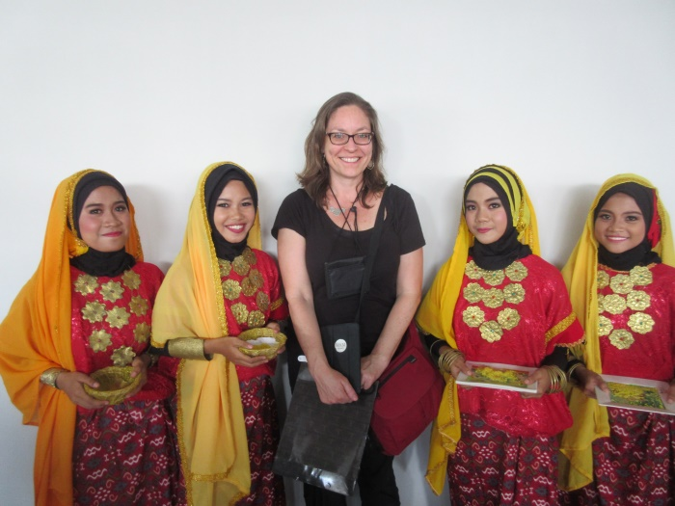
The entire route to our hotel, the Hotel Santika (our group was split into two hotels for the stay with two buses going to the Hotel Santika and two buses going to the Mercure Palu Hotel) was lined with locals witnessing the procession. Children were jumping up and down, waving, and everyone was smiling and waving at the buses. We all, of course, waved back, snapping pictures of this unbelievable spectacle. Disembarking at the hotel after our fifteen-minute transfer, we entered the lobby and were greeted with a dance of welcome by several dazzlingly dressed women. We were then led into a ballroom where we were to be handed our keys and were given welcome drinks and greeted by another ritual dance. There were two persons, a man and woman, dressed like royalty watching the proceedings, and I thought that perhaps they were, in fact, royalty. But then the process of calling names and handing out keys began; it turns out that the two were the front desk staff! They handled the process. Sue and I were the fifth to be called and we made our way up to room 317, the same level as the fitness center (which we didn't use) and the pool (which we did, right away).

We plopped our bags down in our room, changed into our bathing suits and headed down the hall to the pool. The pool was a "rooftop" affair (although there are nine floors and the pool is on the third) that is of the "infinity" variety, overlooking street views. The streets are not what we'd normally see in the USA; they're a strange mixture of modern and third-world. There is clearly a good deal of poverty in Sulawesi, but there are also signs of progress toward the goal of becoming a tourism destination, although I'd guess that with hard work and lots of money it will be another few decades before that becomes a reality.

After swimming, we had a few hours until dinner with nowhere to go. We didn't feel comfortable wandering around the streets here. A few from our group did walk around, but were provided with escorts. Instead of that, we decided to go to the lobby bar for a wine. No wine or even mixed drinks for that matter. But there were two beer options: Bintang and Heineken, both in cans and warm. We chose Bintang at Rp 55,000 each, as did several others from our group that had the same idea. Not familiar with the ways of the west, it seems that the bar was woefully understocked for our group. Runners quickly flooded the local stores purchasing beer and wine for the bar, and one in our group suggested to the bartender that the beer should be cold. At this suggestion, the bartender started putting ice in the gentleman's glass, a misstep that was immediately corrected. After the first day, the beer was served cold in chilled glasses, but since none of the staff knew how to pour a beer, at least this writer would send the server away and pour his own and, most often, Sue's. Another excellent development was that, instead of the small cans of Bintang at Rp 55,000, the restocked beer was large bottles of Bintang, at least twice the size of the cans, at Rp 70,000!

Dinner that evening was in the ballroom and talks were given on the eclipse by Richard Talcott, our celebrity on the tour (he's a senior editor of Astronomy magazine, which I've been reading for around 37 years now). Dr. Talcott’s talk was humorous, informative and excellently crafted. There was also a talk about photographing the eclipse and the latest weather prospects by another speaker. The chances for clear skies were put at around 50%, but the speaker was nonetheless "optimistic."

We went to bed right after dinner for our early start on Eclipse Day!

Eclipse Day

We were awake, as usual, well before the wake-up call and had coffee and tea prior to leaving our room for the lobby. There were boxed breakfasts waiting for us, consisting of a muffin and other pastry and some fruit. There was some coffee available for the bus ride, as well as tea and other liquids. I chose a tea, Sue a coffee. We'd also taken some water from our room, which is complimentary at all of the hotels in this region of the world, it seems. The bus ride was again accomplished with police escort and we were issued security badges since the vice president of Indonesia would be accompanying us for totality. The setting was a school sports field. We (Travel Quest and Asia World groups) had our own tent set up with chairs (plastic, but covered in cloth for our comfort), there was a review stand in the center for the VP and his staff/associates, and there was another tent for other VIPs. Locals lined the fences.

We were told that there would be five toilets set up for our use, but instead, there were zero. This is not a good situation early in the morning, pre-coffee, and we were informed that toilets were set up along the road in mobile vans. Again, they weren't. Finally we were told that a local household would allow use of its toilet, which turned out to be true. To get to the toilets, we needed to exit through the security gate and be escorted down the street to the local house. I was with one of the first groups to go over, which was fortunate because there were only two stalls in the house, and I was eighth in line. When my turn came up, I walked up to the door, opened it, and was surprised and somewhat shocked to see a non-flushing hole in the ground that was installed for the purpose, the sides of which had contoured areas for one's feet so that one could squat over the hole without slipping. Toilet paper was available and there was a large barrel with a scoop inside of it for pouring water into the hole for "flushing." I finished with my business and walked out of the door to the sight of a line that was then around thirty individuals long.

Making my way back to the field I went again through security and walked over to Sue to report on the situation. I suggested that she go right away so that she'd be able to return to the field prior to First Contact, the point at which the Moon first touches the Sun’s face. This she did and was back with around fifteen minutes or so to spare.

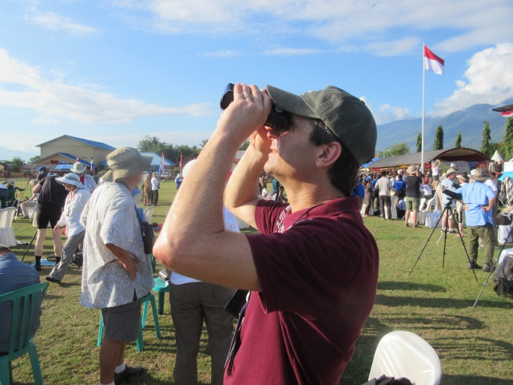
I'd fashioned a crude device for use with my binoculars: I folded over the provided eclipse glasses to form the two lenses into one that was wide enough to cover one lens of my binoculars. I placed the lens cap over the other lens and held the folded contraption tight to the barrel before aiming my device at the Sun. It worked quite well, magnifying the view eight times (8X). Many individuals had solar scopes, including hydrogen alpha scopes (the best kind), that they were quite happy to share with everyone during partial phases. Having attended the annular eclipse in Reno a few years ago, I chose not to wander around looking through scopes since I'd done so at the much smaller event previously, and partial phases are similar for both types of eclipses. I alternated views through my binoculars and using the higher quality solar eclipse glasses that I'd purchased previously for Sue and me (one pair each). At this point, I'd mention that one of our fellow eclipse travelers decided to put his provided eclipse glasses on and look through his binoculars at the Sun. This should never be done, as he found out when the concentrated rays of the Sun immediately burned holes through his eclipse glasses. Luckily his reaction was fast enough to save both his binocular optics and his eyesight. One must always cover the primary lens with proper protection prior to aiming an instrument at the Sun.

First Contact happened right on schedule and the "bite" was visible just a couple of minutes later through my adapted binoculars. This was followed by the "long wait" to totality, which was scheduled for 8:38 AM local time. During the partial phase, we occasionally made note of how shadows were becoming sharper and colors more defined. With around ten minutes to go, it was getting to be like twilight and the crowd was quieting down in anticipation.

I'd seen many photos and read countless descriptions of total solar eclipses over my decades of reading Astronomy magazine, and knew what was going to happen in an academic sense. I wasn't prepared for the excitement of actually witnessing such a spectacle, however, and when totality was imminent I was hyper-focused on the Sun, or the rapidly-shrinking sliver that remained visible. I removed from my binoculars the makeshift solar glasses lens and the other lens cover just as the Diamond Ring effect happened, which was astonishing, and I thrilled as "Bailey's Beads” appeared, just like I'd always read that they should! Then...Totality!

The Sun's corona was stunningly beautiful, with magnetic lines of force clearly visible. The orientation of the poles was at around ten-o'clock and four-o'clock with the corona arcing gracefully from there. Along the ecliptic I briefly glanced over and saw Mercury and Venus relatively close. Saturn, Mars and a few brighter stars, such as Fomalhaut were also visible, as I understand, but I didn't try to see them as I wanted to focus mostly on the Sun. I noted that around 8:30 or 9:00 on the Sun’s face there was a red flare visible and, while watching this amazing sight that was supposed to last for two minutes and forty seconds, I noticed Bailey's Beads at around 1:00, much to my chagrin, then the Diamond Ring, and it was over. Third Contact was in the past and the partial phase leading to Fourth Contact was underway.

I watched as the sun regained its supremacy over the daytime sky, drowning out the planets and stars one by one, leaving, finally, just Venus visible for around twenty minutes. The vice president left and security was packed away, allowing the floodgates holding back the locals to open. We were completely unprepared for what came next.

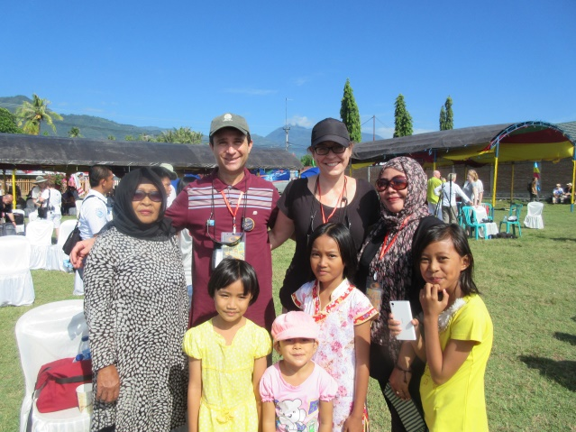
Our guides started to organize our group by the flagpole for a group photo and as we all filed over toward the flagpole, locals would timidly approach, asking for a selfie with us. We all obliged, asking for a photo on our cameras/phones in return. Then, after about twenty of these requests, people became bolder, walking up and asking with no trepidation whatsoever, but never rudely, and always followed by thanks and a handshake. I believe that I can speak for everyone in our group that this made us again feel like celebrities while draining us, both physically and mentally. Finally, as Fourth Contact approached, our guides started to herd us toward the bus and away from the adoring throngs. As we filed onto the buses, groups gathered around them taking more photos and trying to get one last selfie with someone getting on board. We didn't wait for the official end of the eclipse, the aforementioned Fourth Contact, to leave the area and head back to the hotel. Were it up to me, we would have, but it wasn't, and we didn't.

Optional Tour of Palu, Sulawesi

Back at the hotel, we were told that lunch would be at noon and that an optional trip, arranged by the government, was planned for 1:30 to 4:00 and would include a couple of stops. We went to the pool for a quick swim, then to the bar for a beer before lunch. We arrived in the lobby at around 1:15 and departed on the excursion nearly on-time, with full police escort, for our first stop post-eclipse.

The tour started at the king's local meeting house, where, back when there were kings in Sulawesi, he would meet with local politicians and dignitaries to discuss the issues of the day. As with other stops in Sulawesi, crowds were gathered awaiting our arrival and some ritual dances with musical accompaniment were performed in our honor. Locals asked again for photos and posed for some, on their own and with members of the group. A line formed to enter the house, the living areas of which were on the second floor. We were required to remove our shoes and our feet were washed with water prior to entering. Only around twenty-five of us were allowed up at any one time due to the fragile nature of the construction. We suspected that the number was pulled from the air since we were quite certain that there had never been this many visitors to this place at any one time in the past. It worked out, however, since the place didn't collapse while we were there.

There was, on the second floor, an outside porch with some photos of past royal families. The front door led into a large room containing what appeared to be a dining table with chairs, a sitting area and a wardrobe. Rooms off to the right-hand side were bedrooms and private areas. More photos of royal families adorned the walls in the main room and there were mannequins dressed in period clothing as well as other examples of the clothing on hangars. Sue was nervous in there because of the warning about too many people at once, so we made our way back outside to go down stairs on the opposite side of the building from the ones we ascended. While we were inside, our footwear was brought around and a worker arranged them all at the bottom of the stairs on this side. The steps down were treacherous, in that they were oddly angled and spaced, and I'm surprised that no one fell since there were a few less-than-athletic individuals in our group, but no one did. I spotted my shoes and slid right into them from the stairs so that I wouldn't have to walk on the ground with my bare feet, which would have been terrible.

We made our way to the adjacent field to watch some of the ritual dance and music being performed for us. After we watched a couple of dances, we went into the "gift shop" located underneath the house. Sue wanted to purchase a scarf, and I found a nice batik shirt for myself. The scarf was Rp75,000 and my shirt cost Rp 200,000, which amounts to about $6 and $15 or so, respectively. We then made our way back down the path that led to our buses. The sides of the path were lined with locals taking photos, as usual, and they stopped many individuals for selfies. I'd love to be able to see the Indonesian social media with all of the photos of the tourists in Sulawesi.

Our next stop would be a bridge that seemed to have been a big deal and something of which the city of Palu and the island of Sulawesi were very proud. Our buses stopped mid-bridge, which was closed to traffic for our visit that afternoon, and we all disembarked to take photos of the vista and of the bridge itself. A few locals were on the bridge and were snapping photos with those in our group. Sue and I, after a few minutes, got back on board our bus to wait for the trip back to the hotel. This wait was short-lived, however, as our guide stuck his head in the door and said that the local government wished for us to walk down to the bottom of the bridge. We started along our way and were halted around halfway down for another group photo (which ended up in the local paper the next day). Then we saw that there was a parade coming our way.

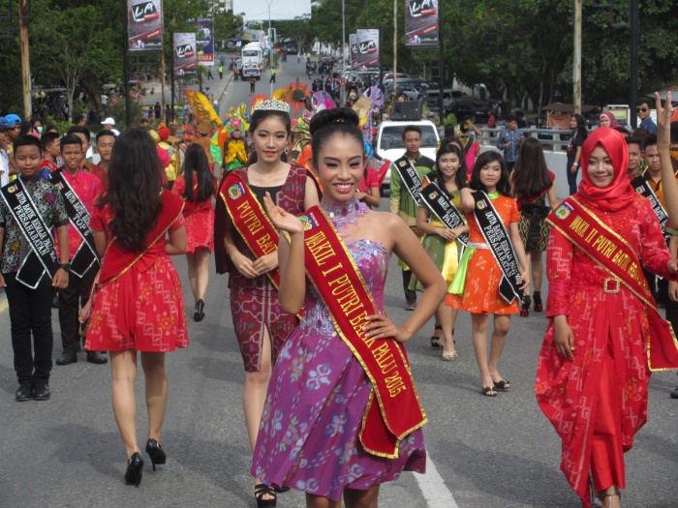
The parade was in our honor, amazingly, and consisted of music and dance, costumes and speeches. People individually and in pairs came before us to show off their costumes and decorations, bowed and moved on, to the enjoyment of everyone involved. After the parade, the participants lined the street that led to our buses and we walked by them, greeting and thanking them for their parade performances. We were then funneled into a small marketplace that was selling various foods, some woven items that were, alas, too large for our suitcases, and some plastic flower arrangements. We didn't purchase anything and went back to the bus to wait.

We arrived back at the hotel just about on time, which was not a normal occurrence on this trip in general up to that point, but it was welcome. This gave us a few hours before dinner, which was to be a celebratory dinner at the other hotel with the entirety of the group. The mayor of Palu was to attend. We had a beer in the lobby, and then went up to our room. I believe we went to the pool for a quick swim, then to the room to relax before dinner.

The buses left for the other hotel nearly on time and we were greeted there by a ritual dance and music (one of the songs was one that we'd seen earlier in the day at the king's house). We were given a welcome drink and shown to the ballroom where our dinner was to take place. There was a house band that played some American-type lounge music and some popular songs, and there was a traditional drum and "flute" music ensemble with traditional dancers. The latter performed some traditional dances and songs, of course, but they also performed one song that was written specially for the occasion of the eclipse, which was excellent (as were the traditional dances). We then had some speeches from our tour guides and from the mayor of Palu, who apologized for any inconveniences that we may have suffered due to us being the first group of any kind to visit Palu, and to the fact that they weren't quite sure how to prepare for such an event. We all assured him that there was no problem at all, for which he seemed relieved and grateful. In fact, the few inconveniences that happened were very quickly addressed; we all thought that the people of Palu and of Sulawesi did a great job taking care of the demands of such a crowd.

Dinner was the usual buffet, and a toast was offered near the end. The drink that was handed out for the toast was some sort of orange wine, which wasn't very good, but our friends Simone and Slade, who were with us at our table, offered some of their wine to us. It was an Italian Sangiovese/Merlot blend, vintage 2011, as I recall, that wasn't too bad. We were also each given one of the flute/recorder-type instruments along with a quick lesson on how to go about using it. After dinner, we made our way back to the hotel and straight up to bed; it had been a long, event-filled day.

Breakfast was in the restaurant, buffet-style, and was very nice. The service was attentive enough, but the place was relatively small, so we shared a table with David Duke and his companion whose name escapes me at this time. The conversation was excellent, and after breakfast we went up to our room to gather our things and get ready for departure. We didn't check baggage, so we just went down to the lobby at the appointed time to wait for the buses.

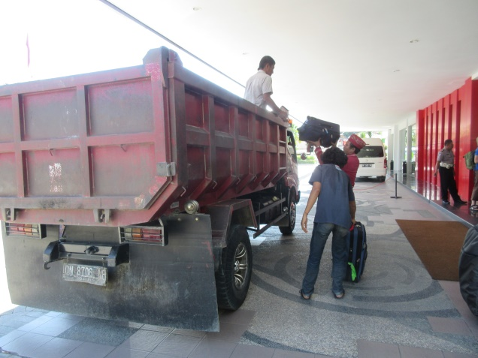
The first vehicle to arrive was a green dump-truck-like vehicle with driver and worker; this was the luggage truck! The bed was filled with luggage and the truck took off, but there was still quite a large amount of luggage left for checking. A short time after the first truck left, a second, red, but otherwise identical, vehicle pulled in. The handlers loaded this truck up and waited there for any last-minute luggage. Meanwhile, our buses started lining up for us. As soon as 1A Bus 2 parked, I got on board and waited for Sue, who didn't see me get on and was momentarily confused.

We arrived at the airport with the usual fanfare, went through a couple of security lines and made our way to gate 7, from which we'd board our plane, an exact duplicate, if not the same plane, as that on which we'd arrived two days earlier. We had seats 30A and 30B for the return trip, but as there were empty seats, we were once again able to stretch out (the gentleman in 30C went to another row and I took that seat). The cruising altitude for the return flight was 38,000' and the expected travel time was 1:40. Lunch was served as soon as the plane leveled off; it was almost identical to the lunch on the flight two days before, and once the trays were cleared we began our descent into Denpasar, Bali.

Back in Bali

We boarded our buses and drove the fifteen minutes or so to the Conrad Bali, where we'd spend the evening. We arrived and were shuffled into the ballroom to get our room keys and enjoy a welcome drink. This time we were assigned room #4224, located fairly close to #4134 which we had the first time, but this was a nicer room, better situated with a nicer deck, living area and bathroom. There was a welcome tray of fresh fruit inside for us. We got changed and went down to the pool for some wine and to take a swim. On the way outside, we stopped by the front desk to arrange for a ride to our next stop, the Palm Gardens Amed Spa and Resort. The clerk made a phone call and told us it would cost $95, to which we agreed. Following our swim and wine, we went back upstairs to get ready for the gala dinner that was being held ocean-side to celebrate the 20th anniversary of TravelQuest, and to mark the end of the Eclipse portion of the tour. Others were going on extension tours to see orangutans and Komodo dragons.

Dinner was buffet style and included beer and glasses of house wine along with soft drinks. We ordered a bottle of wine, for which we had to pay extra. The house band was much better than that of the previous night in Sulawesi; it was clear that these folks made a living this way. Some people even danced on this evening (we didn't). We sat at the table with the trip's celebrity, Richard Talcott, his wife and other traveling companions. There were a few speeches from our guides. Sue and I finished eating and conversing, and then decided to leave the dinner around twenty minutes prior to the end time of 9:00. On our way back to our room we heard fireworks, probably part of the celebration.

The next morning we enjoyed our final meal as part of the TravelQuest tour, then went back upstairs to change up and go do some shopping in the local shops. We went in and out of them all, but didn't end up purchasing anything since nothing quite tickled Sue's fancy. We then made our way back over to the adjacent mini-market where we'd previously purchased a sarong and batik shirt and made several additional purchases: sarongs for both me and Sue as well as two purses for Rp 400,000 (the lady asked for Rp 450,000, but I used all of my newly-acquired bargaining skills and talked her down).

Travel to Amed, Bali

It was after 11:00 and our ride was to pick us up for our trip to Amed at noon. The trip, we were told, would take 3-4 hours, which seemed about right given the distance to the northeast part of the island. We packed and checked out, and our ride arrived right on time. We got into the car and were offered the International New York Times and some water. The paper contained the Friday puzzle, which I eventually completed. Our driver spoke very little English, and we no Balinese, so the conversation wasn't very involved. I was following along on a detailed map of Bali and noticed early on, around an hour in, that it would probably be closer to a three-hour ride rather than a four-hour ride. As we approached Amed, I was able to switch to the inset of Amed for a more detailed view. I knew right where we were, but our driver didn't and stopped to ask directions from a couple of local gentlemen. I tried to show him my map prior to that, but it seemed only to confuse matters. After much bowing and thanking, we were on our way, only around ten kilometers from our destination over a very narrow road that was more like an ox-cart path. Many "resorts" lined this stretch of road, catering mostly, it seems, to divers, Australian divers. I was able to follow along with my map which listed each resort individually, so I knew when we were nearing the Palm Gardens, but had difficulty conveying this to our driver. We passed our destination and by the time I was able to communicate that fact to our driver, we were a little over a kilometer away.

The driver again stopped to ask directions, after backing up in the roadway for a few hundred feet, much to the consternation of other drivers. Once he confirmed that we had, in fact, gone beyond our goal, he made a ten-point turn, again to the consternation of other, eminently patient drivers, and, after exchanging elaborate bows with the other drivers, we made our way back to the Palm Gardens, which we didn't miss this time, and pulled in to the parking area. We tipped the driver Rp 100,000 (which we were told that we didn't need to do, but we felt funny not doing it), and checked in. After check-in we were invited to relax in the open-air lobby and enjoy our welcome drinks, the best by far to that point. Meanwhile, our bags were delivered to our villa.

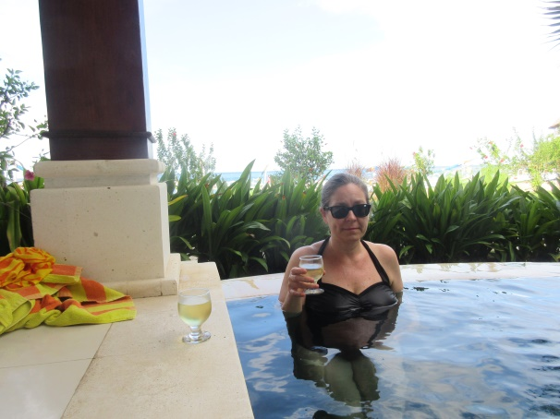
We were assigned Room #10, a villa with an upstairs apartment that we believe is the private residence of the owners, whom we met at dinner the first evening. We also met our neighbors in Room #9, a villa similar to ours but with no upstairs. We had a private pool adjacent to our porch that overlooked the Bali Sea and a bathroom that was open to the outdoors but walled and roofed. The door from the bathroom locked, as did the sliding doors to our porch and the door to the grounds of the resort. There were a mini-bar/fridge, a room safe, queen bed, desk with chair, daybed and dining table and chairs in our room. On the other side of our villa, adjacent to our bathroom, was a private residence that contained, among people and other animals, at least one pig and some chickens, including at least one rooster. There was a large, wide beach in front of our villa lined with fishing boats and a reef suitable for casual snorkeling, which we didn't do, although I swam a couple of times.

There were also some individuals known as “Beach Boys” that walked along the edge of the property asking names, length of stay, welcoming people to Amed and offering all sorts of services: snorkeling, fishing, boat excursions, etc. We were told as we were being shown our room to just smile and say "No, thanks" to any of the offers, otherwise, if, say, one were to say "maybe" or "tomorrow," one would have a difficult time getting free of the constant offers. After a few initial missteps, we learned to do just that. We were also told that if we wanted to do any of those activities, we could arrange it with the front desk and be guaranteed the price; the Beach Boys would invariably up the rate when it was time to pay due to unexpected add-ons. Here is what our in-room guide mentioned, verbatim, about the Beach Boys:

"The hotel can not rent snorkeling equipment and organize this matter together with the local Beach Boy organization. The Beach Boys are not allowed to enter the hotel grounds (Government Rules) Snorkeling equipment - snorkel trips - boat trips - etc. can be organized at reception. We organize this also with the Beach Boy organization. Transactions with the Beach Boys on the beach that do not expire at the reception, must be settled and paid outside the hotel area. Clear agreements concerning price, duration and site quality control protect against unpleasant surprises. Do you want to do business with the Beach Boys, please communicate this clear with "no thanks". Answers like "maybe" or "tomorrow" will be misunderstanding and solve a continuous present tense of the Beach Boys in front of the hotel area from that might disturb your privacy."

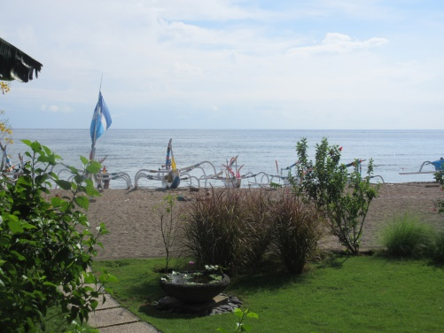
The first thing that we did was hop in the pool, which was pleasantly cool, but not as cool as that of the Alila in Ubud. Certainly it wasn't warm like the water in the pool at the Conrad Bali. Following our comfortable dip, we donned some clothing and went over for a bottle of local Balinese wine called Aga White (Hatte Wines), billed as "An aromatic dry white wine from the vineyards of Bali." First of all, I'd like to say that this was the best of the white wines we'd yet had on Bali. One of the previous ones, the "cheap" one that we were enjoying almost exclusively while at the Conrad Bali, listed at Rp 450,000 on the menu. Another listed for Rp 950,000, and one at the Alila, judging from the final cost, must have listed at around Rp 695,000 or so. This bottle was on the menu at the Palm Gardens for Rp 200,000! Other items there were similarly inexpensive, and we purchased quite a few items from the gift shop: four sarongs, two necklaces and a hanging fish tea-light candle holder.

Dinner was included (we booked our stay with "full board") and every item is fresh and made to order. Our neighbors and one other couple were the only guests. Our neighbors were from Switzerland, and the gentleman originally started speaking to me in German. Noting my confused expression, he asked whether I spoke "Deutsch," which I don't, then "Francoise?": another no. Then I asked, "English?" and he started speaking to me in English, with only slight problems with colloquialisms, which is to be expected. I've had quite a bit of practice, by now, and try to speak only with proper rules and phrases to those for whom English is not a first language, which seems to help quite a bit with conversation, as I'd imagine it would were the tables turned.

While ordering our dinner, we tried to get a red snapper dish that said it was suitable for two and was "market price," but were told that we'd need to order it that night for the following evening, because they needed to order it from the fishermen, and we agreed and placed our order for the following evening. While eating, the waitress approached, apologetically, explaining that there was no red snapper available as the fishermen had been experiencing an absence of that fish of late, so we asked about the mackerel, another choice, to which she replied that they should be able to get that, so we revised our next evening's meal order accordingly.

The next day, after breakfast (we'd decided to relax at the resort on our first full day on our own in Bali) but before lunch, we went over to the front desk to arrange for a tour that would have us climb up 1,725 steps to the top of a temple, and to stop by some gorgeous rice terraces of which we'd caught a glimpse on the way in. There was no driver available for the following day (the 13th), because he was otherwise engaged, but the front desk clerk said she'd check on his availability on the following day for us, and said the tour would start at around 8:00, but she'd let us know later on after she called him. After lunch, I arranged for a ride on the 15th to our next destination because, since there seems to be only one driver, I wanted us to be first in line for him. That ride was eventually arranged for around noon on the 15th.

The mackerel dinner was excellent and very fresh, although Sue and I needed to remind ourselves of the process of deboning a whole fish. They were a bit smaller than usual, so we each had our own plate and our own fish. After dinner we stayed up for a little while but turned in relatively early, hoping to see the fishing boats leave the next morning. That morning we’d awoken early, but the boats were already gone. By the time we were eating breakfast, at 7:00, the boats were beginning to come back in. Anyway, the following morning we again awoke early, but the beach was clear of fishing boats.

After breakfast, we took a quick swim and enjoyed the sights of the boats coming back in from their morning run. This is a process that takes a good amount of time, furling sails, hauling in motors and nets, running fish to the various restaurants and resorts and carrying boats up, often with six or eight individuals cooperating, to their spots on the beach.

Sue finally decided on this day to send out some laundry. We'd been looking for a laundry bag in the room, but there definitely was not one in there, even though there was supposed to be one. She went to the front desk and asked for one, which she was able to get quickly from the clerk, and came back to the room. We filled the bag and she ran it back over to the front desk, asking how long it would take? No answer. Then she asked how much it would be. No answer. So she came back to the room.

For lunch, after another swim or two, we each had the same order: tuna salad (Western-style, supposedly, although not really) and a mixed salad containing lettuce, carrots, tomato, cucumber, corn (!) and a house dressing that was Italian-y, but with a more lemon-leaning than vinegar flavor. We then went back to the room to swim and relax, awaiting our dinner time. It was tough-going on the northeast coast of Bali for a few days.

We ordered a bottle of white wine for the room to enjoy in the early afternoon at the pool, then got ready for and arrived at dinner for the start time of 7:00 PM. Sue ordered the fish dish wrapped in banana leaf (which we'd tried on our first evening here) and I decided on some deep fried fish balls. Both dishes come with vegetables and rice (Sue's white and slightly crunchy and my own yellow (buttery) and soft, both with fried onion on top). We also had salads to start: Sue a papaya salad, me a cucumber and tomato salad. We split a large bottle of water.

After dinner, we went to bed early for our trip to the temple (Pura Lempuyang) in the morning.

Pura Lempuyang

I awoke to darkness and looked out of our windows to see the fishermen with flashlights preparing to set out for their daily expedition. I mentioned it to Sue, but she didn't get up to see. After that, I went back to bed and got up at 6:00 to get ready for breakfast at 7:00. We'd be leaving by 8:00 for the temple. Our driver was waiting in the lobby when we got there at around 7:50 AM. He introduced himself, we were handed water and sarongs (for the temple) from the front desk clerk and we were on our way.

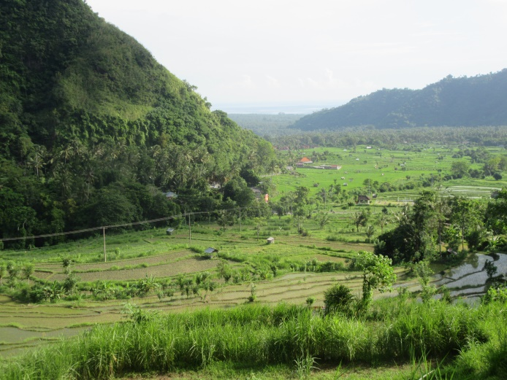
A short distance from the hotel, our driver asked whether it was OK for him to pick up another passenger (his brother, I think) who was going to retrieve a motorbike from their mother's house, a request to which we raised no objections. His brother was sitting on the side of the road a few minutes' distance from the hotel and got into the front seat. We dropped him off at the motorbike pick-up area and continued on our way to the temple. Along the way, our driver pointed out where we were going from a bridge by the Bali Sea and mentioned that we'd be able to see that very bridge from the temple (we could). We also stopped at the Rice Terraces (you can look these up) to take a few photos; Sue stayed in the car.

The road leading up to the temple parking area, which is large enough for maybe four or five cars, was winding and narrow, much like HI450 on Moloka'i's eastern end. It is always a little unnerving to travel up that high on such a road with other traffic making its way down, but we try to not worry too much about that while we're in the middle of it, and we arrived safely at the parking area. We were greeted by someone who seemed to wield some authority, letting us know that our sarongs could be donned at this point and showing us a book where we could sign in, which we did, and told us that we could feel free, but not obligated, to make a donation to the temple, which we did (Rp 50,000). We were the first visitors for the day (there aren't too many during the rainy season). He also showed us a map of the paths leading to the temples, of which there are quite a number in addition to the main one. It may have been a sales pitch, but he also told us that after the second temple, the forest was somewhat thick with monkeys and maybe we'd want a guide to avoid going the wrong way and to help protect against monkeys, to which we agreed. Sue was nervous about the monkeys, and I had my fill of trying to follow hand-drawn maps, such as the one he showed to us, because of the Ubud debacle, so we agreed to a guide for Rp 400,000.

He called someone from a shop across the street and a small girl started making her way over toward us; I assumed that this diminutive person would be the one to summon our guide, whom I pictured as being a strapping twenty-something native with a club or machete for protection. In fact, the person turned out to be his daughter, and he handed her a stick, telling us that she was to be our guide and protector. Her height was somewhere around 4-1/2' and she was perhaps 20 years old, if that. She introduced herself as Eluh, and she turned out to be a very good guide that spoke reasonably good English. However, she wasn't in the best of shape and was visibly struggling during parts of the trek, which was good because Sue didn't want to go too fast, either.

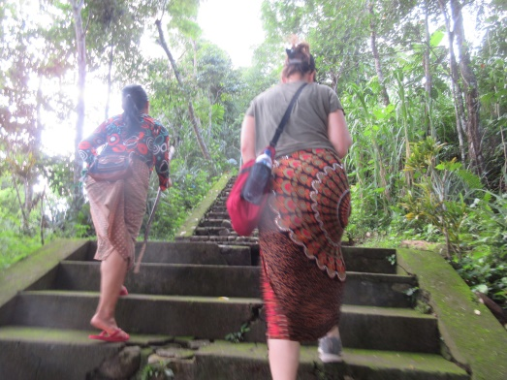
The first temple was upon us quickly, and I was heartened, thinking that this wouldn't be too difficult. The first temple is the one in all of the photos that one sees on the web pages for this attraction. We took a few photos and walked on. A short time later we came to a bend in the road with ten or twelve motorbikes and drivers to the side, offering a ride to the second temple (Rp 20,000 each), which we declined, since we wanted some exercise and since Sue would never get on one of those vehicles. So we soldiered on up a relatively steep road for around 1/2-mile or so until we reached the second temple. At this point, we were all a little heated, and about done with our waters, so I purchased two more waters from a woman at the side of the road for Rp 5,000 each. I asked Eluh if she wanted one, but she said "Maybe later."

After a short rest and a few photos at this temple, we resumed our walk. Adjacent to the second temple were some stone steps that Eluh said was the start of the advertised 1700+ steps (stairs) to the main temple. This wasn't the best news I’d ever received, but we wanted to get some exercise, so we started in. I was happy, too, because it gave me a starting point for counting, which I did. (To add a little harmless suspense to the report, I'll not reveal just yet how many stairs I counted from this point up to the main temple.)

Along the way, Eluh would stop and point out nice views of Mount Agung, of Mount Serayia and Mount Nampu and other sights that were visible at certain points such as rice fields and neighboring islands (which she hadn’t yet visited). I took many photos and also announced my step count every 100 stairs or so, usually at landings where people would take a short break. There were at least four different little "shops" on this climb in the middle of this monkey forest that sold snacks, juices, soda and water. There were also several women that were carrying sacks of cement and sand, weighing up to around 25 kilos each, on their heads up to the main temple. Eluh said that some days the women make ten trips up and back with these burdens on their heads. The main temple is being renovated for a big festival scheduled to take place in 2019. The most recent renovation was 25 years ago. The temple itself, the oldest temple on Bali, is over 2,000 years old.

We saw no monkeys on the way up, and 1,731 stairs later (with some stretches of "flat" walking in between) we were standing atop the main temple! We were discussing it somewhat loudly, much to my eventual chagrin, because as we turned a corner around one of the temple structures, there was a group of individuals praying solemnly, maybe fifteen or so strong. I immediately quieted down, making awkward conciliatory gestures at the worshipers that turned around to see who was acting so boorishly. Eluh said that we could feel free to take photos of them as long as they were from the back, never from the front.

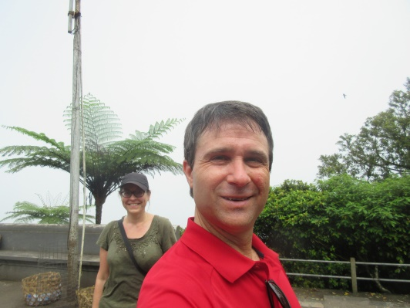
After looking around a bit, we went down to the next platform and Eluh recited a history of the temples, the theory behind the worshiping and the worshiping requirements on individual Balinese, daily and otherwise. One of the many interesting things that she mentioned is that the cremation ceremony is extremely expensive, prohibitively so, so most villages hold only one ceremony every five years and that perhaps fifteen families will partake in it so that the costs can be shared. I didn't ask about storage of the bodies until the ceremony, but I remember something from my pre-trip reading that mentioned that the bodies are stored in temporary graves and then removed from them for the ceremony, at which time they are cremated.

On the walk back down we had the option of taking a side loop that would have brought us to five more temples, but we decided to just go straight down, which turned out to be a good choice for at least two reasons: one, our legs weren't too accustomed to all of the stair-stepping and we were both pretty shaky on the way down, and two, it started to rain rather heavily just as we reached the bottom and the stairs would have gotten very, very slick. Also, Sue didn't want to run into any monkeys. As it was, I had to walk behind her, with Eluh in front, in the unlikely event of a monkey attack. So we were back in the car and heading to the Palm Garden by 11:30 AM. That was long enough. The drive took around 40 minutes, so we were able to shower and use the pool before lunch at 1:00 PM.

For lunch, Sue chose a mixed salad, mie goreng w/ egg and a pineapple juice. I chose Spaghetti Al'Tonno (with tuna), a Greek salad and a lemon juice. The Greek salad was cucumber, tomato, onion, black olives and feta cheese (no lettuce) with a very tasty dressing, and the lemon juice was a fresh lime juice. All of the food was excellent and much appreciated after such a vigorous morning. Once back in our room, the waitress delivered our afternoon snack of watermelon with fresh lime to squeeze over it, which Sue says could be the new snack offered at the YBH in the afternoon to our guests, should they occur.

We swam in our pool for a bit, read, looked at our devices and watched the general goings-on on the beach for the afternoon. There was a brief downpour, as it's the rainy season, then it cleared up and we headed over to dinner. Sue decided on the fish cooked in banana leaf again, and I tried some fish skewers. My skewers came presented on a tiny grill with lion faces on either end, and four feet shaped like paws. There were some hot coals in the grill and eight skewers with three cubes of fish each on them, each topped with a pineapple chunk. There was a plate accompanying this presentation with a nice, spicy brown sauce for the fish along with the normal white rice and vegetables. Had I tried this earlier, I would have ordered it at least twice, but as it was, I was happy to have tried so many Balinese specialties at the Palm Garden Amed such as the one on this night. We had a few sips of wine with dinner and took the rest of the bottle back to the room with us.

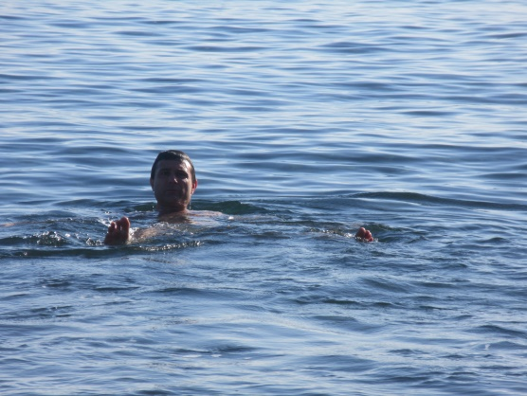
The next morning we had our usual breakfast, right at 7:00 AM and followed that with a morning swim in our pool. I read for a while and Sue looked at her device. I realized that there were, as yet, no photos of me in the Bali Sea, so I went down there for another brief swim while Sue took some shots of me and of the fishermen coming in from their morning excursions. The sea is warm and calm in the Amed area and well-suited for reef diving and snorkeling, which seems to be the main attraction around those parts. A morning watermelon snack was brought to us by the kitchen staff. As much as we didn’t wish it, the time eventually arrived when we needed to be packed up for our check-out and departure. Made (our driver from the temple trip the day before) was scheduled to pick us up at noon for our transport down to Seminyak to the Villa Bali Asri, about a three-hour drive with no traffic.

We were ready to leave our room at around 11:40 (Sue wanted to do some shopping in the gift shop before we left) and I started putting my bags outside the front door. As soon as I put them down to go back in for Sue's, the maid ran up from somewhere and grabbed them to bring them to the lobby (I told her she didn't need to do that, but she insisted). I took Sue's bag and my hotel-issued sarong along with a hotel-issued umbrella (there was a brief downpour) and went to the lobby with Sue. The owners were there to see us off, but I explained that Sue wanted to do a bit more shopping, which she did (two more sarongs and a hair clip; I picked out a Palm Gardens Amed t-shirt for myself). We chatted with the owners for a while about various things: their schedule, the grounds, the food, the workers, the seasons, etc. While I was doing that, the front desk clerk was doing her tally on Sue's recent shopping spree to add to our total. I added that total to the one that I'd calculated, added three percent for a MasterCard surcharge (collected by the hotel) and checked my figure against that of the front desk clerk, and it was an exact match, so I paid the bill.

At this point, I had exactly Rp 217,000 in cash left, Rp 100,000 of which I kept back for a tip for Made for today's drive. The rest, Rp 117,000 I threw into the Tip Box at the front desk for the various workers at the hotel; not enough, in my opinion, but it was the remainder of my funds, so it would have to do. The clerk seemed happy nonetheless. By this time, Made showed up and the maid had delivered all of our bags to his van, so we shook hands all around, the front desk clerk gave us a couple of waters and they all saw us off at the van, waving as we pulled away.

Seminyak, Bali

The ride took around 3:15 due to some heavy traffic in the Denpasar area. I followed along on my map, as I like to do, and made note of the places where the route that I'd thought we'd take differed from that taken by Made (it turns out that his choices made more sense). His name, by the way, is pronounced mah-day, but he said it's spelled just like made: "Made in Amed!" he said with a laugh, since he was born and raised there. The streets leading up to the hotel, once we were in Seminyak, became more and more narrow until they ended up being the size of a typical sidewalk in Cambridge, and made of some sort of cobblestone material. I spotted the hotel as we were passing it and alerted Made, who pulled into the small unloading area. We took our bags, I tipped him and he shook our hands, then he was on his way back to Amed.

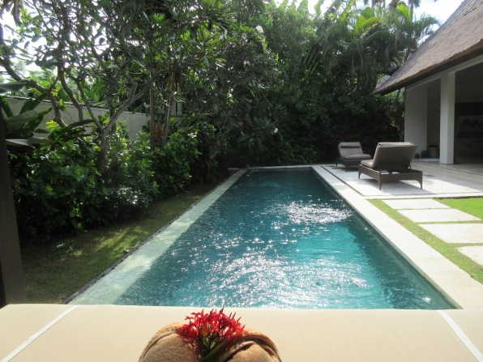
We checked in and were shown to Villa 1, our room for the next day. The door was wooden and it opened onto a path through a small pond-like walkway area around to where the private pool, pool chairs and cabana were located in the private courtyard. Facing the large pool was the living area consisting of couch, "coffee table" (I put this in quotes because the carved behemoth is nothing like any coffee table I know, but I don't know what else to call it) and what I like to call a mini-courtyard of plants that is sofa-sized behind the sofa. A dining table and chairs was adjacent to this area and a well-appointed kitchen with island was behind that. The bedroom was behind two wooden doors off of the dining area and consisted of a large closet, king bed with mosquito netting, desk with chair, chair and television. There was also a small selection of books available on the library-type headboard. The outdoor bathroom, much like the one that we had in Amed, was off the back of the bedroom. The bedroom had sliding doors opening onto the pool area near the cabana. This may have been the nicest place we've ever stayed.

We were given a menu for breakfast, which was included, and I told the front desk our order for the next morning at 8:00 AM. The chefs would come to our room at that time and make our breakfast for us, but more about that a bit later.

I'd made reservations for us to dine at the Ku De Ta, of which the Bali establishment is the flagship of that high-end dining chain. Sue and I previously had a meal at the Ku De Ta located at the top of the Marina Bay Sands in Singapore with Cheryl Tng and Richard when we visited that city a few years prior and expected a similar experience here. The room information packet mentioned that this particular Ku De Ta was a nice local hangout and a good bar from which to view the sunset. I decided to wear my nicest batik shirt to the restaurant and Sue chose her heavenly orb-themed batik dress purchased at the same place at which I found my shirt. We both figured these outfits would be nicely in line with the dress code of "smart casual." They were, but there were also people dressed in bathing attire and in t-shirts, jeans, etc., so I don't know what "smart casual" means, I guess. I did notice that others were either searched on their way in or asked at the front gate their business at this restaurant, whereas we were just waved right in.

We arrived around twenty minutes ahead of our 6:00 reservation time, but we wanted to walk around for a while and decided to have a cocktail before dinner, so it was OK. The host said they'd seat us whenever we were ready to eat regardless, so there was no problem all around. This place is vastly larger than the Singapore establishment with three bars downstairs and at least that many upstairs and at least six separate seating areas. I enjoyed a couple of whiskeys that were described as a "pour" but turned out to be about 3/4 finger apiece, and Sue had a couple of glasses of Sauvignon blanc. If we ordered these things in NYC, my drinks would have listed for at least $30 each, I'd guess, but here they were a much more reasonable $9 (including service charge and tax). We watched some surfing on the Java Sea from our bar stools and people at the Ku De Ta enjoying their pool and extensive yard, many with children and babies, which didn't make us particularly happy, but the music was sufficiently loud and distracting to cover up any unpleasant child noises. The music skewed old, which was surprising, concentrating on beat-ified versions of songs such as "Welcome to the Machine," "Walk on the Wild Side," and 80s one hit wonders. All seemed to be Balinese remakes with people that almost, but not quite, sounded like the original artists.

At around 6:05 we went up to the host's desk and said we were ready to be seated. The host showed us two menus from which we could chose, one a tasting menu and the other a la carte. I noticed right away that the second course on the tasting menu didn't have anything we'd eat, so we opted for the latter and were led toward the outdoor tables. I asked to be seated inside, and we were shown to a beautiful table just under the overhang leading to the yard - inside, but yet somewhat outside. It was a great view of the surf, the sky and the sunset and it was under some ceiling fans so that there was a nice, steady breeze with no insects.

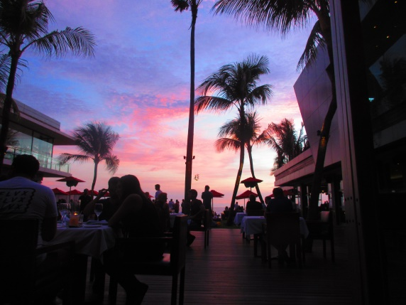
We ordered a bottle of wine from our server, Romen, as well as a tuna tartare app, a corn soup app (one each of both of those) and a goat cheese app to share. We also each ordered the swordfish dinner (without pork jowl) as well as a couple of salad sides and a potato puree side to share. The tuna appetizer is the best I've ever had, as was the corn soup and, may I add, the goat cheese. The swordfish was perfectly done, but perhaps Tom's is a bit better, and the mashed potatoes, for that's what they were, rivaled my own. The pea pod salad was tasty as was my cucumber/tomato salad, but neither were particularly spectacular. We each ordered a dessert, I a lemon-lime meringue pie type of thing with sorbet and a thin chocolate-y hat over the sorbet and Sue had crème fresh gelato with passion fruit sauce and raspberry with brown sugar cake. She claimed it was the best dessert she'd ever had; my own was close.

We ordered a bottle of wine to bring back to the room and paid our bill. The walk back was a bit worrisome, as it was along the narrow streets again and we needed to dodge traffic a bit, but we made it. We decided to pour a glass of wine and go for a dip in the pool. All of the lights were turned on and the mosquito netting was over the bed. We enjoyed a glass of wine in the pool and then went to bed.

The next morning I awoke at around 6:20 AM and started a pot of coffee in the kitchen. We enjoyed a few cups of coffee with "full cream milk" that was in the fridge, and then got ready for breakfast. We were all set for the chef's arrival by around 7:40 AM, so we sat on the couch and read for a bit. 7:51, then 7:58, 7:59...right at 8:00 sharp, there was a knock on the door and two chefs were there with all of the necessary ingredients in hand for the breakfast we ordered. I'd arranged for coffee, mango juice, and an "American" breakfast with vegetables and cheese omelets.

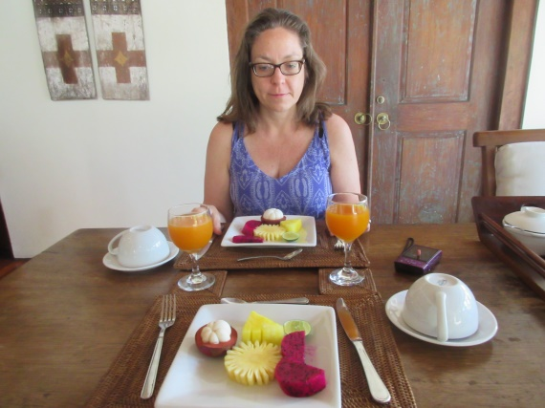
The two went straight to work and five minutes later we sat down to fresh fruit plates consisting of mangosteen, pineapple, dragon fruit, yellow watermelon and lime along with our mango juices and coffee. When we were just about finished with the fruit plates, a plate of toast and croissants along with our omelets were delivered to our table. While we ate, the two chefs sat down on the floor behind the island in the kitchen. When we finished, they gathered and washed the dishes, put them away, and bid us a good morning. The time was 8:27 AM.

After breakfast, we took a swim and discussed going into town to do a bit of shopping. I asked the front desk clerk for a recommendation regarding a shopping area, and he pointed us out the way that we walked to get to Ku De Ta, but instead of turning left as we did to get to the restaurant, to turn right and we'd find the Seminyak Market. That sounded promising, so we gathered up what we'd need for a bit of shopping before finding a place for lunch.

We found the market with no problem whatsoever. It was just a short distance from Ku De Ta, and consisted of a row of permanent storefronts as well as several rows of tents offering flea-market type sales. Most of the permanent stores took credit cards, but the tents took cash only. Sue wanted to get a bag to carry onto the planes, and I wanted a shot glass and a wood carving, perhaps of Ganesh. With that in mind we started along the stretch of permanent stores, and Sue found a couple of possibilities regarding bags and I spotted some shot glasses. We then made our way over to the tents where we found more bags and some nice carvings, which I looked over. I found a Ganesh that I liked quite a bit and the lady asked Rp 550,000 for it. I balked, and counteroffered Rp 350,000. She said Rp 450,000 and I offered Rp 400,000. She came back with Rp 420,000 and I said I'd have to think about it and started walking out. She said, OK, Rp 400,000 for good luck, OK mister? And I said it's a deal and that I'd go to the ATM for the money.

Meanwhile, Sue found a bag that we bargained, in a similar manner, down from Rp 450,000 to Rp 300,000, so I went to the ATM to withdraw Rp 700,000. We paid for our merchandise and went back to one of the permanent stores where Sue purchased another bag (for Rp 280,000), a fancy skull and a shot glass for her work friend. I added a shot glass for myself to the mix and we paid for all of that with a credit card. Unfortunately, the person minding the store wasn't familiar with credit cards, so a person from a neighboring store came over to help out. After adding a 3% surcharge to our total, they ran the card and the slips came out of the machine, which further confused the person at the store, so I took the credit card machine, ripped off the two slips, signed one and gave it to the gentleman and took the other with my card, thanked him, and left the store.

After our purchasing, we went to the end of the market area where there were several restaurants. We looked over all of the menus, but Sue didn't like the look of the restaurants, the food on the menus, or the state of the menus themselves, which she found to be somewhat dirty, so we walked out to the street and found a decent Italian-looking place called La Sicilia. It was 11:45 AM, and the place didn't open for lunch until 12:00 PM, but they invited us in to have a drink at the bar until they were ready in the kitchen for us. While we were enjoying a glass of wine, four Customs agents entered the place and started asking for documentation and taking ladders looking here and there. None of this interfered with our drinks or, eventually, with our lunch, which was excellent. Apparently there was no problem because after a little while, maybe 30 minutes or so, they left, seemingly satisfied.

After lunch, we made our way back to the hotel where we enjoyed a leisurely afternoon in the pool and around our room. We went out to the lobby at around 3:20 PM to wait for our ride to the airport. We had a nice conversation with the clerk about where we were from, what we'd done in Bali and Sulawesi for the past couple of weeks, what snow was like, how long our trip would take and whatever happens to all of that snow in the spring and doesn't everything get very wet when it melts? Our ride showed up at around 3:35 and we loaded our bags and got in. This ride was included with our rate, as was breakfast and that incredible villa. We’d paid a total of $258 for the night. Amazing.

Travel to Dudley, MA

The ride to the airport took around 25 minutes, because we arrived almost exactly at 4:00 PM for our 7:00 PM flight. We checked our bags, got our passports stamped and made our way to the gate area, which we found by around 4:30 PM. Having nothing to do for a while, we stopped in at the Hard Rock Cafe for a couple of glasses of wine.

The trip home was the reverse of the trip over. Many movies were seen, meals eaten, etc. For example, on the Doha, Qatar to Philadelphia, PA, USA leg, I watched four movies and three documentaries: “Star Wars: The Force Awakens,” “Hitchcock,” “Far From the Madding Crowd,” “The Peanuts Movie” and all three episodes of “Great Wild North.” The flights were fine and relatively uneventful. I found it interesting that on Qatar Air, part of the loop of the 3D Maps screens was a representation of the plane on its course with a compass around it showing in which direction Mecca is located and how far away it is, just in case one needed to know that.
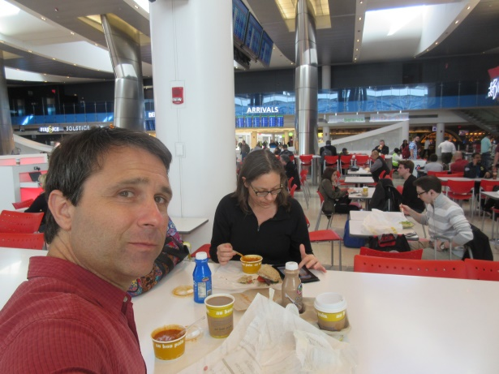
The final leg in the air was a 34-minute flight from PHL to BDL after we went through customs at PHL. I was able to use the Global Entry kiosk, but Sue had to wait in line. It took me about 30 seconds, but Sue was in line for around 20 minutes or so. We ate lunch at Au Bon Pain while waiting for our flight. At BDL, we quickly collected our bags and took the shuttle back to the car. We were home around an hour and ten minutes later, at 2:45 PM, thirty-five hours and fifteen minutes after leaving the Villa Bali Asri in Seminyak, Bali, Indonesia. We stayed up until 7:00 PM to try to get back on schedule, and awoke at around 5:30 AM the next day. I was OK, but Sue still needed several more nights to get over the jet lag.

Musings

There are a few topics that I think would be nice to summarize regarding the island of Bali, Indonesia: driving, people, eating, drinking, and getting around.

Driving

If you’re considering going to Bali and renting a car to drive yourself around, don’t. The traffic is completely unlike any I’ve witnessed anywhere else in the world and unlike any that I or any readers of this report have ever experienced. Roads are typically extremely narrow, causing one car to go to the side of the road while the other passes, but when the car goes, say, over to the left to allow passage of another vehicle, the blinker used is the one on the right, maybe to let the person know that he/she can pass on that side. Also, there is a constant tooting going on, always short and usually accompanied by a nod from each driver to the other. The purpose of the toots seems to be varied: you can go around me; you can pass by me going the other way; I’m coming up to a curve; there’s someone passing me; I’d like to pass you; thanks for letting me pass you; you’re welcome; please wait while I turn my vehicle completely around in the road. And there are no fewer than fifty small motorbikes for every one car-like vehicle, which fill around the other non-motorbike vehicles like grains of sand at every stop light, intersection or even just flowing along in traffic. They pass around curves, on the left, on the right, in between two vehicles going in the opposite direction, you name it. And there are very few helmets worn by motorbike riders, and plenty of passengers and very large, unstable looking loads. Drivers of the motorbikes are supposed to be licensed and at least 16 years of age, but there are numerous very small children driving the units on the roads. Also, passengers are often babies just balanced in front or small children or others riding side-saddle in the back, not holding onto anything. So please, don’t drive while visiting Bali; you’re not ready for it.

People

The people are unfailingly polite and helpful. They shake your hand with both of theirs and bow all of the time. Usually they don’t accept a tip (although in a few cases, they did), and employees of the hotels will not allow any of their guests to handle a bag. Period. Also, the level of education is often very low, but most people speak at least a small amount of English. I made it a habit of putting both hands together in front of me while bowing slightly to indicate thanks, and I also tried to not point at anything with my left hand, trying instead to use the more polite thumb of my right hand with my four fingers tucked under my palm.

Prices

Prices on Bali are extremely inexpensive in most cases. There are some items that can be pricey, such as some bottles of wine, but there are also less expensive options, especially local Bali wine, that is much more reasonable and quite tasty. Depending on where one purchases other items, such as batik, paintings or jewelry, one can run the gamut of price points. However, for the most part, bargaining is expected and the starting prices are usually pretty low regardless.

Eating

One should eat only in well-established restaurants that are obviously frequented by tourists and avoid the small roadside stands. Bali Belly is a real thing and is not too hard to contract. The source is never clear, though, and it can happen regardless of precautions. That said, one should enjoy local Balinese dishes and cooking to the greatest extent possible. The flavors are bold and often quite spicy, and the ingredients are unfailingly extremely fresh, from locally caught fish to fruits and vegetables harvested within a stone’s throw. One thing that is everywhere available but which I still have not tried is durian. It’s said that this fruit “smells like hell but tastes like heaven,” but I have yet to find out first hand.

Drinking

Get accustomed to drinking warm beverages, because ice is often contaminated and will cause the aforementioned Bali Belly; not to locals, who are immune, but to tourists. Stay away from frozen cocktails, etc., and even non-alcoholic frozen fruit drinks. But don’t avoid the fresh fruit juices. We tried papaya, guava, watermelon, lemon (which seems to be what the Balinese call a lime), carrot w/ ginger, mango and banana juices, all excellent and made fresh to order with local ingredients. We know that the ingredients were fresh because if we’d order something, the waitress would sometimes return and apologize, saying something like “I’m sorry, but the mangoes are too small to make nice juice today.”

Getting Around

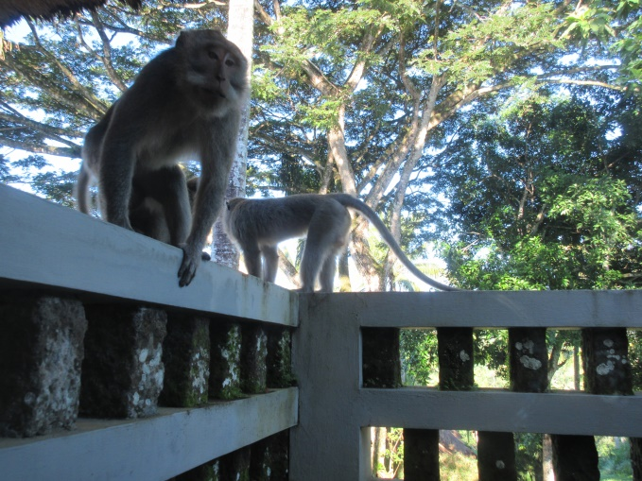
Hire a driver if you want to go anywhere (see “Driving,” above). It’s inexpensive – e.g., we had a 3:15 ride from Amed to Seminyak, from which the driver then had to return to Amed, and it cost Rp 750,000, or around $58, to which we added a Rp 100,000 tip for a total cost of around $65 – and it’s much safer than any other option.

